Wenatchee Valley Stormwater Technical Advisory Committee

Stormwater Pollution Prevention

Operations and Maintenance Plan Template

for Eastern Washington NPDES Phase II Communities

Funded by:
Washington State Department of Ecology

Prepared by:
Otak, Inc.
6 South 2nd Street, Suite 605
Yakima, WA 98901
Otak Project No. 31703

October 2010
Template Users:
Refer to the Stormwater Pollution Prevention O&M Plan Template Guidance Document (Otak, October 2010) for instructions on how to use this template to develop a stormwater O&M Plan that is specific to your community.

<CITY/COUNTY NAME>

Stormwater Pollution
Prevention

Operations and Maintenance Plan

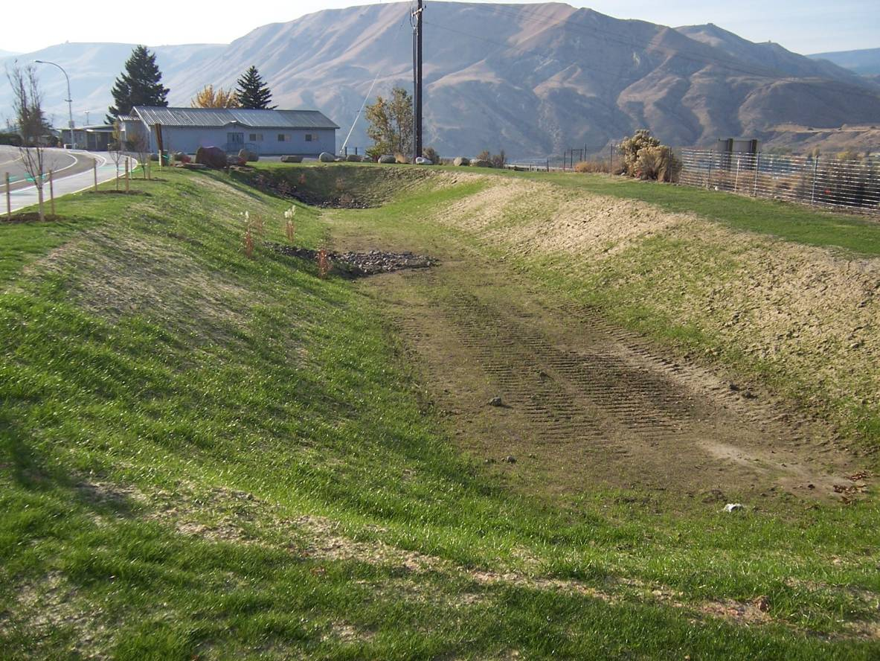

<City/County>
<Address>
<City, State, Zip>
<Date, 2010>


<INSERT YOUR LOGO HERE

Acknowledgements

The template for this Stormwater Pollution Prevention Operations and Maintenance Plan was developed by Otak, Inc. for the Wenatchee Valley Stormwater Technical Advisory Committee, consisting of representatives from the City of Wenatchee, the City of East Wenatchee, Chelan County, and Douglas County. Contributions to the project were made by other Eastern Washington communities, including stormwater program managers from the Cities of Kennewick, Moses Lake, Richland, Spokane, and Spokane Valley, Spokane and Walla Walla Counties, and the Eastmont Metropolitan Park District. The Operations and Maintenance Plan Template project was funded by a grant from the Washington State Department of Ecology.

Sections
Glossary iii
Acronyms and Abbreviations v
Section 1—Introduction 1-1
Section 2—Program Overview 2-1
Section 3—Stormwater Collection and Conveyance System 3-1
Section 4—Roads, Highways, and Parking Lots 4-1
Section 5—Vehicle Fleets 5-1
Section 6—Municipal Buildings 6-1
Section 7—Parks and Open Space 7-1
Section 8—Construction Projects 8-1
Section 9—Industrial Activities 9-1
Section 10—Storage Areas 10-1
Section 11—Flood Management Projects 11-1
Section 12—Other Facilities and Activities 12-1
Section 13—Planning, Budgeting, and Recordkeeping 13-1

Appendices
Appendix A—Stormwater Facility Inspection Checklists
Appendix B—Waste Disposal Protocol
Appendix C—Private Facility Inspection and Enforcement Protocol
Appendix D—SWPPP Template
Appendix E—Integrated Pest Management Policy
Appendix F—Staffing and Equipment Spreadsheet

Figures
Figure 2-1—Map of Stormwater System 2-4
Figure 2-2—Map of Municipal Facilities 2-5

Tables
Table 1-1—Common Stormwater Pollutants, Sources, and Impacts 1-2
Table 2-1—Summary of Major Stormwater Management Facilities 2-2
Table 3-1—Implementation Checklist for Stormwater Collection and Conveyance System 3-1
Table 3-2—Stormwater Facility Inspection Frequencies 3-3
Table 4-1—Implementation Checklist for Roads, Highways, and Parking Lots 4-1
Table 4-2—Street Sweeping Schedule 4-2
Table 5-1—Implementation Checklist for Vehicle Fleets 5-1
Table 6-1—Implementation Checklist for Municipal Buildings 6-1
Table 7-1—Implementation Checklist for Parks and Open Space 7-1
Table 9-1—Examples of Facilities that Require an Industrial Permit 9-1
Table 12-1—Implementation Checklist for Other Facilities and Activities 12-1

The majority of the definitions below are sourced from the Washington Department of Ecology (Ecology) Eastern Washington Phase II Municipal Stormwater Permit (Phase II Permit). Definitions not provided from the Phase II Permit were taken from other sources, including Ecology’s Stormwater Management Manual for Eastern Washington and EPA’s NPDES website glossary.
<Review definitions for consistency with local codes, etc.>

Best Management Practices (BMPs) | The activities, prohibitions of practices, maintenance procedures, and structural and/or managerial practices that, when used singly or in combination, prevent or reduce the release of pollutants and other adverse impacts to downstream or down gradient systems.
Catch Basin | A drainage structure which collects water. May be either a structure where water enters from the side or through a grate.
Conveyance System | The drainage facilities, both natural and man-made which collect and carry surface and stormwater flow. Includes gutters, drainage inlets, pipes, catch basins, manholes, channels, swales, ditches, small drainage courses, streams, and rivers.
Drywell | A stormwater disposal system designed to disperse water below the land surface. Drywells are regulated by the Department of Ecology under the Underground Injection Control (UIC) program.
Erosion and Sedimentation Control (ESC) | Any temporary or permanent measures taken to prevent erosion and sedimentation, such as preserving natural vegetation, seeding, mulching and matting, plastic covering, and sediment traps and ponds. Erosion sediment control BMPs are synonymous with stabilization and structural BMPs.
Groundwater | Water in a saturated zone or stratum beneath the land surface.
Hazardous Substance | 1) Any material that poses a threat to human health and/or the environment. Typical hazardous substances are toxic, corrosive, ignitable, explosive or chemically reactive. 2) Any substance designated by EPA to be reported if a designated quantity of the substance is spilled in the waters of the United States or is otherwise released into the environment.
Hyperchlorinated | Water that contains more than 10 mg/Liter chlorine. Disinfection of water mains and appurtenances requires a chlorine residual of 10 mg/L at the end of the disinfection period. This level is well above the Maximum Residual Disinfectant Level of an annual average of 4 mg/Liter chlorine for potable water.
Illicit Discharge | Any discharge to the municipal separate storm sewer that is not composed entirely of storm water except discharges pursuant to a NPDES permit (other than the NPDES permit for discharges from the municipal separate storm sewer) and discharges resulting from fire fighting activities.
Maintenance | Activities conducted to extend the life cycle and ensure proper operation of existing facilities. Maintenance should not expand the use or capacity of a facility beyond the existing or designed use and results in no significant adverse hydrologic impact.
Maintenance Standard | Describes the condition when cleaning, repair, or other maintenance is required for a given facility.
Manhole | An entrance provided to a drainage facility for the purpose of inspection and cleaning. This may consist of a circular manhole shaft, frame and round cover or an opening into a structure where the top of the structure is at the surface. The opening may be round or rectangular.
Material Storage Facility | An uncovered area where bulk materials (liquid, solid, granular, etc.) are stored in piles, barrels, tanks, bins, crates, or other means.
National Pollutant Discharge Elimination System | The national program for issuing, modifying, revoking, and reissuing, terminating, monitoring and enforcing permits, and imposing and enforcing pretreatment requirements, under sections 307, 402, 318, and 405 of the Federal Clean Water Act, for the discharge of pollutants to surface waters of the state from point sources. These permits are referred to as NPDES permits and, in Washington State, are administered by the Washington Department of Ecology.
Oil/Water Separator | A vault, usually underground, designed to provide a quiescent environment to separate oil from water.
Phase II Permit | Eastern Washington Phase II Municipal Stormwater Permit, issued by the Department of Ecology on January 17, 2007 and modified June 17, 2009.
Pollutant | A waste material that pollutes wind, water, or soil. A non-stormwater discharge that enters the stormwater collection and conveyance system.
Receiving Waters | Any water body receiving stormwater runoff, including surface water, groundwater, and the stormwater collection and conveyance system.
Sediment | A naturally occurring material that is broken down by weathering and erosion and transported by wind, water, or other fluids.
Stormwater | Rainwater runoff, snowmelt runoff, and surface runoff and drainage.
Swale | A shallow drainage conveyance with relatively gentle side slopes, generally manmade.
Water Quality | The chemical, physical, and biological characteristics of water, usually with respect to its suitability for a particular purpose.
Waters of the State | Those waters as defined as “waters of the United States” in 40 CFR Subpart 122.2 within the geographic boundaries of Washington state and “waters of the state” as defined in Chapter 90.48 RCW, which include lakes, rivers, ponds, streams, inland waters, underground waters, salt waters, and all other surface waters and water courses within the jurisdiction of the State of Washington.

BMPs | Best Management Practices
CONSTRUCTION PERMIT | General NPDES Permit for Stormwater Discharges Associated with Construction Activities
ECOLOGY | Washington State Department of Ecology
EPA | Environmental Protection Agency
FTE | Full Time Equivalents
INDUSTRIAL PERMIT | General NPDES Permit for Stormwater Discharges Associated with Industrial Activities
NPDES | National Pollutant Discharge Elimination System
O&M | Operation and Maintenance
PHASE II PERMIT | Eastern Washington Phase II Municipal Stormwater Permit
RCRA | Resource Conservation and Recovery Act
SWPPP | Stormwater Pollution Prevention Plan
UIC | Underground Injection Control

This page intentionally left blank.

Purpose

The <CITY/COUNTY> is currently subject to the requirements of both the National Pollutant Discharge Elimination System (NPDES) Eastern Washington Phase II Municipal Stormwater Permit (Phase II Permit) and the Underground Injection Control (UIC) Rule. Under the Phase II Permit, <CITY/COUNTY> is required to develop and implement a municipal Operations and Maintenance (O&M) Plan to protect water quality and reduce the discharge of pollutants into receiving waters. Receiving waters include surface waters, groundwater, and the stormwater collection and conveyance system.

The <CITY/COUNTY>’s municipal employees engage in a number of activities that may positively or negatively impact water quality. This O&M Plan includes stormwater pollution prevention and good housekeeping practices that should be utilized during municipal maintenance activities in the following areas:
- Stormwater Collection and Conveyance System,
- Roads, Highways, and Parking Lots,
- Vehicle Fleets,
- Municipal Buildings,
- Parks and Open Space,
- Flood Management Projects, and
- Other Facilities and Activities.

This O&M Plan also addresses stormwater pollution prevention during Construction Projects and Industrial Activities. Appendix D has a site specific Stormwater Pollution Prevention Plan (SWPPP) for the <CITY/COUNTY>’s municipal Storage Areas.

O&M Plan Development

This Stormwater Pollution Prevention O&M Plan was prepared based on a Stormwater Pollution Prevention O&M Plan Template developed by Otak, Inc for the Wenatchee Valley Stormwater Technical Advisory Committee using funding provided by a Washington State Department of Ecology (Ecology) Grant. The inspection schedules, maintenance standards and Best Management Practices (BMPs) included in this plan are based on Ecology’s Stormwater Management Manual for Eastern Washington (2004), the Model Municipal Stormwater Program for Eastern Washington, and other guidance documents from Ecology and EPA.

Common Pollutants, Sources, and Impacts

Stormwater runoff contains pollutants that can harm human health, degrade water quality and habitat, and impair ecosystem functions. These pollutants originate from vehicles, businesses, homeowner activities, and municipal activities, and include oil, hydrocarbons, heavy metals, deicers, sediment, pesticides/herbicides, fertilizer, and bacteria. During rain and snow melt events, stormwater runoff may accumulate these pollutants which are then washed into the receiving waters. Table 1-1 shows the sources of common stormwater pollutants and the potential impacts.

Table 1-1
Common Stormwater Pollutants, Sources, and Impacts
Pollutant | Sources | Impacts
Sediment | Construction sites; eroding stream banks and lakeshores; winter sand and salt application; vehicle/boat washing; agricultural sites. | Destruction of plant and fish habitat; transportation of attached oils, nutrients and other pollutants; increased maintenance costs, plugged conveyance systems, flooding.
Nutrients  (phosphorus, nitrogen) | Fertilizers; malfunctioning septic systems; livestock, bird & pet waste; vehicle/boat washing; grey water; decaying grass and leaves; sewer overflows; leaking trash containers, leaking sewer lines. | Increased potential for nuisance or toxic algal blooms; increased potential for hypoxia/anoxia (low levels of dissolved oxygen which can kill aquatic organisms).
Hydrocarbons  (petroleum compounds) | Vehicle and equipment leaks; vehicle and equipment emissions; pesticides; fuel spills; equipment cleaning; improper fuel storage & disposal. | Toxic to humans and aquatic life at low levels.
Heavy Metals | Vehicle brake and tire wear; vehicle/equipment exhaust; batteries; galvanized metal; paint and wood preservatives; fuels; pesticides; cleaners. | Toxic at low levels; drinking water contamination.
Pathogens  (bacteria) | Livestock, bird and pet wastes; malfunctioning septic systems; sewer overflows; damaged sanitary lines. | Risk to human health leading to closure of shellfish areas and swimming areas; drinking water contamination.
Toxic Chemicals | Pesticides; dioxins; Polychlorinated Biphenyls (PCBs); spills, illegal discharges and leaks. | Toxic to human and aquatic life at low levels.
Debris/Litter | Improper waste disposal and storage; fishing gear; leaking rubbish containers; cigarette butts; littering. | Potential risk to human and aquatic life, aesthetically displeasing, can plugged conveyance systems, flooding.
Source: Rabasca and Rinehart, 2006

What are Best Management Practices (BMPs)?

BMPs are the activities, actions, procedures, prohibitions of practices, structural facilities, and/or managerial practices that, when used singly or in combination, prevent or reduce the release of pollutants into receiving waters.

There are three broad categories of BMPs:
- Operational BMPs are those activities and actions that municipal staff should perform on a regular basis to prevent the release of pollutants into the stormwater system. For example, street sweeping is an operational BMP. Putting tarp over material stockpiles at the end of each day is an operational BMP.
- Structural BMPs are permanent facilities or structures that are constructed to prevent pollutants from coming into contact with stormwater. For example, constructing a roof over a material storage area is a structural BMP.
- Treatment BMPs are the facilities that are used to remove pollutants from stormwater before it is released downstream into the surface waters or groundwaters. For example, oil/water separators and vegetated swales are Treatment BMPs.

This O&M Plan is focused on operational and structural BMPs that will be utilized to protect the <CITY/COUNTY>’s receiving waters. Section 3 also describes the maintenance of the <CITY/COUNTY>’s existing stormwater treatment BMPs, as regular maintenance is required to keep treatment BMPs functioning as they are intended.

Management Considerations
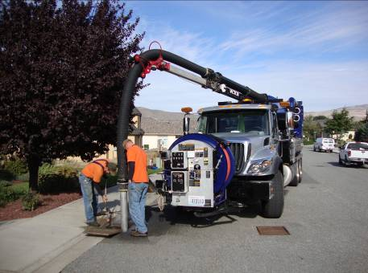
Preventing stormwater pollution during maintenance activities is a significant responsibility that impacts the activities of nearly every department in the <CITY/COUNTY>. Maintenance activities must be carefully planned, coordinated, and documented to meet the requirements of the Phase II Permit, avoid duplication, and make best use of limited staff time and resources. Section 13 of this O&M Plan describes the planning, budgeting, and recordkeeping activities associated with stormwater pollution prevention and good housekeeping during municipal maintenance activities.

This page intentionally left blank.

Organization/Structure

The <CITY/COUNTY> <DEPARTMENT> is primarily responsible for the maintenance of the <CITY/COUNTY>’s stormwater infrastructure. This includes inspecting and cleaning catch basins and manholes, clearing roadside ditches, and maintaining stormwater treatment and disposal facilities.

In addition, many other <CITY/COUNTY> departments conduct municipal activities that have the potential to introduce pollutants into stormwater. To protect receiving waters from stormwater pollution, the following <CITY/COUNTY> departments are covered under this Stormwater Pollution Prevention O&M Plan:
- <ROADS/STREETS>
- <FLEET/VEHICLES>
- <BUILDING MAINTENANCE>
- <PARKS/OPEN SPACE/LANDSCAPING>
- <OTHER>

Stormwater Infrastructure Inventory

The <CITY/COUNTY> completed a mapped inventory of the public stormwater infrastructure in <YEAR>. A map of the publically operated stormwater system is included as Figure 2-1. The inventory is continually updated as new structures and facilities are added to the system. As of <DATE>, the <CITY/COUNTY>’s stormwater system was comprised of approximately:
- <NUMBER> catch basins and manholes
- <NUMBER> miles of storm sewer pipe
- <NUMBER> miles of conveyance ditches
- <NUMBER> drywells
- <NUMBER> stormwater management facilities (see Table 2-1)
- <NUMBER> surface discharges to the <NAME> River, <NUMBER> discharges to the <NAME> River, and <NUMBER> discharges to Lake <NAME>

<Insert information in Table 2-1 for stormwater detention and treatment facilities – ponds, swales, tanks/vaults, infiltration trenches, proprietary devices. Communities with a large number of stormwater management facilities may elect to move this table to an appendix.>

Table 2-1
Summary of Major Stormwater Management Facilities
Name/Number/Designator | Facility Type | Location/Address | Year Constructed
ex. West Hills Pond | ex. Treatment pond | 12345 W. Hilly Avenue | 200X
ex. State Street Vault | ex. Detention Vault | State Street between 1st and 2nd Avenue | 200X

In addition to the stormwater system owned and operated by the <CITY/COUNTY>, there are a number of private stormwater management facilities that are owned and operated by commercial/industrial businesses or residential homeowners associations. The <CITY/ COUNTY>’s program related to private facility maintenance is discussed in Section 3.

Facilities, Equipment, and Storage Areas

The <CITY/COUNTY> is responsible for the operation and maintenance of a number of municipal facilities as shown in Figure 2-2. These facilities include:
- <CITY HALL>
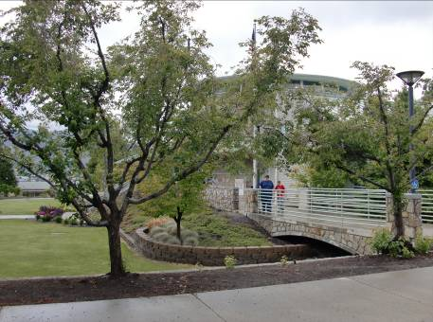
- <PUBLIC WORKS BUILDING>
- <COMMUNITY CENTER>
- <MATERIAL/EQUIPMENT STORAGE YARD>
- <VEHICLE SHOP>
- <MAJOR PARKS -OR- NUMBER OF PUBLIC PARK PROPERTIES>
- <OTHER>

Contracted Activities

The <CITY/COUNTY> typically contracts with private companies to perform the following maintenance activities:
- <LIST>
- <LIST>
- <LIST>

Private contractors performing work on behalf of the <CITY/COUNTY> are also subject to the provisions protecting stormwater runoff. This O&M Plan should be referenced when preparing contract documents.

Insert Figure 2-1 Map of Stormwater System, including:
- Pipes
- Ditches
- Catch Basins and Manholes
- Drywells
- Stormwater Management Facilities
- Outfalls

Insert Figure 2-2 Map of Municipal Facilities, including:
- Municipal buildings (including community centers operated by the city/county),
- Municipal parking lots > 5,000 sf
- Vehicle, equipment, and material storage yards
- Parks and open space properties
- Other (treatment plants, airports, etc)

Table 3-1
Implementation Checklist
Stormwater Collection and Conveyance System
Potential Pollutants: Sediment, Nutrients, Hydrocarbons, Heavy Metals, Pathogens, Toxic Chemicals, Debris/Litter
 | Current Activity | Required New Activity* | Optional | Responsibility
Catch Basin Inspection and Cleaning – 30% inspected and cleaned annually | X |  |  | Personnel
Catch Basin Inspection – 100% of high priority areas inspected annually |  |  |  | Personnel
Catch Basin Inspection – 50% of all other areas inspected annually
Catch Basin Cleaning – Clean structures based on inspected conditions |  | X
Stormwater Facility Inspections – 100% Inspected Annually |  | X
<ADD MORE ELEMENTS>
<ADD MORE ELEMENTS>
<ADD MORE ELEMENTS>
<ADD MORE ELEMENTS>
*All required new activities must be implemented prior to the August 2011 to be in compliance with the Phase Permit.
< The table above is an example and should be tailored to the unique maintenance program of your jurisdiction. List current maintenance activities/frequencies, required new (or changed) activities, and optional activities – those items that maintenance crews should address as staff/time/budget are available.>

Overview

The <DEPARTMENT> is responsible for maintenance of the stormwater collection and conveyance system, including catch basins and manholes, pipes, ditches, and stormwater management/treatment facilities. Maintenance activities focus on removing sediment, debris, and pollutants from the stormwater system, before they can be flushed downstream into receiving waters, resulting in adverse effects on aquatic life and water quality. Regular maintenance is also needed to keep stormwater management facilities (e.g. detention ponds, treatment swales) functioning as they were designed.

Maintenance for the stormwater collection and conveyance system consists of inspection, cleaning, repairs, and replacement. The Phase II Permit requires a shift from responsive maintenance to preventative, standards-based maintenance. Regular inspections will be used to identify when cleaning or repairs are needed to keep the stormwater system functioning at an optimal level. The maintenance activities should then be performed, utilizing the BMPs in this section.

The activities related to stormwater collection and conveyance system maintenance that are covered in this O&M Plan include:
- Facility Inspections
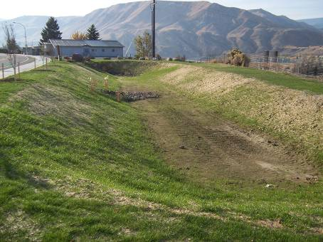
- Conveyance System Maintenance
- Stormwater Management Facility Maintenance
- Small Construction Activities
- Waste Disposal
- Private Facilities
- Recordkeeping

Facility Inspections

The Phase II Permit requires regular inspection of the <CITY/COUNTY>’s stormwater facilities to check system performance and identify maintenance needs. Stormwater facility inspections will be performed by <TITLE/DEPARTMENT>.

Inspection Schedule
Table 3-2 shows the proposed inspection frequencies for each type of stormwater management facility. Most stormwater management facilities will be inspected on an annual basis. Drywells and other UICs will be inspected twice-yearly. Catch basin and roadside ditch inspections are scheduled based on priority areas. High priority areas are those areas that are subject to major sanding or neighborhoods with significant tree cover. High priority areas will be inspected annually and low priority areas will be inspected every three years on a rotating schedule.

- <Frequencies in black are those required by the Stormwater Management Manual for Eastern Washington (Sept 2004). Adjust other frequencies if needed. Delete or add facility types as they apply to your jurisdiction.
- For catch basins and ditches, identify high priority areas where winter sanding and/or tree cover causes requires frequent cleaning. Geographically divide other areas for inspection on 3 year rotation.
- Schedule/stagger inspection seasons as needed to accommodate crew workloads. When possible, schedule catch basin cleaning to coincide with street sweeping.>

Table 3-2
Stormwater Facility Inspection Frequencies
Facility Type | Inspection Frequency | Timing
Management Facilities
Oil Water Separators | Monthly in the Wet Season | October through June
Drywells | Twice Yearly | <MONTH> <MONTH>
Infiltration Basins and Trenches | Twice Yearly | <MONTH> <MONTH>
Treatment Swales | Annually | <SEASON>
Tanks and Vaults | Annually | <SEASON>
Ponds (Detention, Water Quality, Evaporation, Infiltration) | Annually | <SEASON>
Control Structures | Annually | <SEASON>
Sand Filters | Annually | <SEASON>
<Proprietary Treatment Devices> | <Manufacturer Recommendation – annual?> | <SEASON>
<Other>
Conveyance System
Catch Basins: <High priority area> | Annually | <SEASON>
<1/3 of low priority areas> | Year A | <SEASON>
<1/3 of low priority areas> | Year B | <SEASON>
<1/3 of low priority areas> | Year C | <SEASON>
Roadside Ditches: <High priority area> | Annually | <SEASON>
<1/3 of low priority areas> | Year A | <SEASON>
<1/3 of low priority areas> | Year B | <SEASON>
<1/3 of low priority areas> | Year C | <SEASON>
Culverts | Annually | <MONTH OR SEASON>

Inspection Activities
During inspections, field inspectors should utilize the inspection checklists in Appendix A to document the condition of each facility and identify any required maintenance activities. Any identified maintenance needs should be reported to <TITLE>, so that work orders can be developed to complete the required repair or cleaning.

In addition to documenting the condition of each stormwater facility, field inspectors should continually verify and update (as needed) the <CITY/COUNTY>’s inventory map. Field inspectors should immediately report any spills or illicit discharge concerns to <NAME>.

Standards and BMP Selection

The Stormwater Management Manual for Eastern Washington includes required facility maintenance standards related to the physical condition and function of each type of stormwater management facility. The maintenance standards cover topics such as sediment depth, erosion, vegetation growth, accumulated trash and debris, and structural integrity. For example, one of the maintenance standards for catch basins states that a structure should be cleaned when sediment exceeds 60 percent of the sump depth or when sediment has accumulated to within 6 inches of the lowest pipe invert.

The inspection checklists in Appendix A list the required maintenance standards for each type of stormwater management facility. Field inspectors should use the checklists during regular inspection to indicate when cleaning or repairs are needed. The Phase II Permit then requires that the <CITY/COUNTY> to correct an observed problem “…as soon as practicable” after the condition is identified during a regularly scheduled inspection or spot check.

Beyond the inspection requirements, the Phase II Permit requires the <CITY/COUNTY> to prevent the discharge of pollutants to the stormwater system and protect water quality to the maximum extent practicable. The following operational and structural BMPs will help the <CITY/COUNTY> meet the permit requirements.

<Unless otherwise indicated, the BMPs in the remainder of Section 3 are required by either the Phase II Permit, the Stormwater Management Manual for Eastern Washington, or Ecology’s UIC rule.>

Conveyance System Maintenance

The following BMPs apply to the maintenance of the stormwater collection and conveyance system, including catch basins and manholes, outfalls, pipes, ditches, and drywells. Regular inspection and cleaning of catch basins and manholes should reduce the need for frequent cleaning of storm sewer pipes.
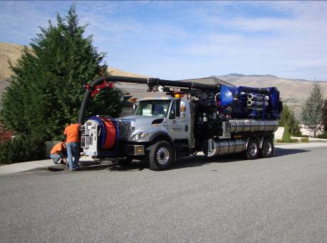

Operational BMPs
- Regularly inspect catch basins and outfalls according to the inspection schedule outlined in this O&M Plan to determine maintenance. Complete maintenance activities as identified during inspections.
- Clean catch basins and manholes when sediment and debris exceeds 60 percent of the sump depth or when sediment has accumulated to within 6 inches of the lowest pipe invert.
- Clean storm sewer pipes when accumulated sediment and debris exceeds 20 percent of the pipe diameter.
- Clean roadside ditches when accumulated sediment and debris exceeds 20 percent of the design depth.
- Conduct ditch cleaning during low water periods, minimizing the disturbance of existing vegetation.
- Test and dispose of sediment and debris according to the Waste Disposal Protocol in Appendix B.
- If vegetation is removed during ditch cleaning, the ditch side slopes should be seeded and mulched as soon as possible after cleaning.
- Develop a “hot spot” list of frequent flooding locations. Conduct spot checks of those locations following major precipitation events, exceeding <1.3> inches of rainfall in any 24 hour period. <Insert 10-year precipitation value from isopluvial maps. 1.3 inches is conservatively low for most areas of Eastern Washington.>
- Implement the <CITY/COUNTY>’s Illicit Discharge Detection and Elimination Program to regularly inspect outfalls for evidence of unreported spills, illicit connections, or illegal dumping.
- Register all UIC wells with Ecology. Required information includes: operator/owner information, site location (latitude and longitude), BMPs used to protect groundwater quality, and a UIC well description.
- Complete a UIC well assessment, evaluating the potential for pollutants to enter the stormwater runoff that flows to each UIC well. The well assessment should consider land use and groundwater protection areas and may consider local geology and depth to groundwater for wells that are considered a high threat to groundwater.

Structural BMPs
- <Recommended>Stencil drywell and catch basin grates with, “Dump No Waste - Drains to Stream/Groundwater".
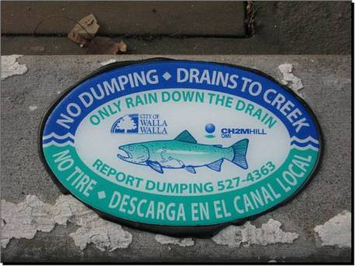
- Prioritize, schedule, and complete repairs and replace damaged components of the stormwater conveyance system identified during inspections.
- <Recommended>Retrofit UIC wells identified during the well assessment as being high threats to groundwater. A retrofit may include changing the source control activities and/or Structural BMPs around the well, adding an upstream catch basin or spill control device, adding pretreatment facilities, and/or well decommissioning. For more details, see the Ecology document entitled, Guidance for UIC Wells that Manage Stormwater, Publication Number 05-10-067.

Stormwater Management Facility Maintenance

The following BMPs apply to the maintenance of stormwater management facilities, including detention and infiltration ponds, underground tanks and vaults, treatment swales, oil/water separators, and proprietary treatment devices.

Operational BMPs
- Regularly inspect stormwater management facilities according to the inspection schedule outlined in this O&M Plan to determine maintenance. Complete maintenance activities as identified during inspections.
- Remove sediment when it exceeds the sediment storage depth (typically 12 inches) in ponds or when it exceeds 15 percent of the vault storage depth or tank diameter.
- Remove sediment when it exceeds a depth of 2 inches in treatment swales.
- <Recommended>Whenever possible, coordinate catch basin cleaning to coincide with municipal street sweeping.
- Test and dispose of sediment and debris according to the Waste Disposal Protocol in Appendix B.
- Develop a “hot spot” list of major stormwater retention facilities. Conduct spot checks of those locations following major precipitation events, exceeding <1.3> inches of rainfall in any 24 hour period. <Insert 10-year precipitation value from isopluvial maps. 1.3 inches is conservatively low for most areas of Eastern Washington.>

Structural BMPs
- Prioritize, schedule, and complete repairs and replace damaged components of the stormwater conveyance system identified during inspections.

Vegetation Management BMPs
- <Recommended>Mow vegetation in ponds and swales at least once per year to prevent the establishment of woody vegetation.
- <Recommended>If vegetation is removed during sediment removal, seed and mulch the area as soon as possible after cleaning.
- <Recommended>Follow the <CITY/COUNTY>’s Integrated Pest Management Policy in Appendix E to manage vegetation without the aid of fertilizers. <OR> Use integrated best management practices that consider cultural, biological, mechanical, or engineering controls before chemical controls.
- <Recommended>Use mechanical methods of vegetation removal rather than herbicides.

Small Construction Activities

Sediment and erosion control measures should be implemented when stormwater system repair or replacement projects include grading, soil transfer, or vegetation removal. The following BMPs apply when making structural repairs or replacing components of the stormwater infrastructure.

Small Construction BMPs
<All BMPs below are recommended for small construction projects. These BMPs (and many others) are required for sites subject to the NPDES Construction Permit (i.e. sites larger than one acre).>
- Minimize land disturbance and exposed slope length.
- Whenever possible, avoid land disturbance during the wet season.
- Implement erosion control techniques or devices to stabilize disturbed areas. Use mulch or other erosion control measures when soils are exposed for more than a week.
- Install storm drain inlet protection on all inlets within <500 feet> downstream or down gradient of the project site to prevent coarse sediment from entering the drainage system. Inlet protection methods include block and gravel inlet protection, gravel and wire inlet protection, and catch basin inserts. Inspect inlet protections frequently during construction.
- Remove excess soil from the site as soon as possible after backfilling to eliminate sediment loss from surplus fill.
- Obtain a General NPDES Permit for Stormwater Discharges Associated with Construction Activities from Ecology for any project that disturbs one or more acres and has the potential to discharge to a water of the state.

For larger construction projects that include the addition of new stormwater system components or the replacement of culverts in streams or other perennial water bodies, follow the construction activity guidelines in Section 8.

Waste Disposal

Waste generated from cleaning of catch basins and other stormwater management and treatment facilities must be disposed of according to the requirements of <LOCAL SOLID WASTE AGENCY>. In some cases, the waste material must be tested to determine the proper disposal method. Material in catch basins with obvious contamination (unusual color, staining, corrosion, unusual odors, fumes, and oily sheen) should be left in place or segregated from other wastes until testing results can identify the nature of the contaminants. The <CITY/COUNTY>’s waste testing and disposal protocol is included in Appendix B.

Private Facilities

In addition to the stormwater system owned and operated by the <CITY/COUNTY>, there are a number of stormwater facilities that manage stormwater runoff from private property. These facilities are owned and operated by private property owners – either commercial/industrial businesses or residential homeowners associations. While the maintenance of these systems is the responsibility of the private owner, the <CITY/COUNTY> is required to establish a private facilities maintenance program for facilities that discharge to the <CITY/COUNTY>’s stormwater collection and conveyance system or to local receiving waters. The purpose of the program is to verify that maintenance is performed and the private facilities are functioning to manage and protect water quality.

The private facility maintenance program is administered by <TITLE/DEPARTMENT>. Details of the program are described in Appendix C.

Recordkeeping

Recordkeeping is a condition of the Phase II Permit. <NAME/TITLE> is responsible for keeping records of stormwater collection and conveyance system maintenance activities. In accordance with the Phase II Permit, the following documentation must be kept for at least five years following work activity:
- Inspection schedules and checklists for stormwater treatment and flow control facilities;
- Records of spot checks performed following major storm events,
- Repairs or maintenance actions completed as a result of inspections and spot checks,
- Number and type of enforcement actions related to private facilities, and
- Number and type of illicit discharges detected and eliminated.

In addition, tracking the following information may be helpful in planning and budgeting for future maintenance activities. See Section 13 for additional information.
- Catch basins cleaned each year,
- Amount of sediment collected and date removed, and
- Results of sediment testing.
<These record keeping suggestions are optional. List those that are applicable, useful, and practical for your jurisdiction.>

Hard copy reports should be stored in <LOCATION>. <OR> Hard copy documents should be scanned for electronic storage in <LOCATION>. Inspections, catch basin cleaning, and facility maintenance should also be imported into the <CITY/COUNTY>’s GIS system, so the <TITLE> can geographically track maintenance activities and plan for future work.

In addition, material or liquid spills should be promptly reported to <NAME> and all paperwork related to the spill and cleanup activities should be maintained at <LOCATION.>

This page intentionally left blank.

Table 4-1
Implementation Checklist
Roads, Highways, and Parking Lots
Potential Pollutants: Sediment, Hydrocarbons, Heavy Metals, Toxic Chemicals, Debris/Litter
 | Current Activity | Required New Activity* | Optional | Responsibility
Sweep major arterials annually | X
Sweep major arterials quarterly |  | X | X
Sweep all residential streets annually prior to the wet season | X |  | X
Store sand stockpile under cover |  | X
Add elements
Add elements
Add elements
*All required new activities must be implemented prior to the August 2011 to be in compliance with the Phase Permit.
< The table above is an example and should be tailored to the unique maintenance program of your jurisdiction. List current maintenance activities/frequencies, required new (or changed) activities, and optional activities – those items that maintenance crews should address as staff/time/budget are available.>

Overview

Pollutants accumulate on roadway surfaces and parking lots from pavement and vehicle wear, atmospheric deposition, and littering. Hydrocarbons, copper, and other heavy metals are deposited on roads from clutch and break wear, vehicle exhaust, and leaking motor fluids. Degrading road surfaces, litter, and trash, also add pollutants to stormwater runoff. Anti-icing chemicals that include acetate can deplete dissolved oxygen, increase conductivity, and increase pH of receiving waters. Sand used for winter traction can accumulate in the stormwater collection and conveyance system, carrying pollutants into receiving waters. If not properly managed, regular municipal street maintenance activities can negatively impact the health of local aquatic resources.

The <DEPARTMENT> is responsible for implementing this O&M Plan during maintenance of the <CITY/COUNTY>’s roads and highways. The <DEPARTMENT> is responsible for implementing this O&M Plan during maintenance of all municipal parking lots over 5,000 square feet. This includes:
- <LIST>
- <LIST>
<List municipal parking lots over 5,000 sf>

Stormwater pollution prevention during roadway and parking lot maintenance focuses on collecting sediment, debris, and pollutants before they can enter the stormwater collection and conveyance system. This plan also covers proper vegetation management and application and storage of materials used for snow and ice control.

Standards and BMP Selection

The Phase II Permit does not include specific maintenance standards or BMPs related to the maintenance of roads, highways, and parking lots. The <CITY/COUNTY>’s obligation is to prevent the discharge of pollutants to the stormwater system and protect water quality to the maximum extent practicable. To meet that goal, the <CITY/COUNTY> has identified BMPs related to each of the following activities:
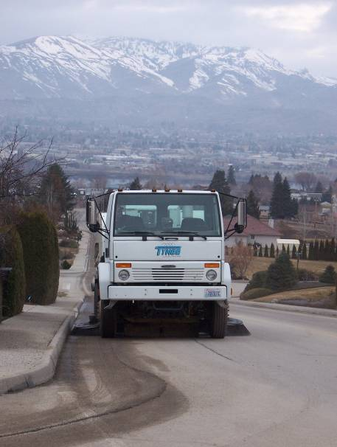
- Street Sweeping
- Winter Activities
- Street Repair and Maintenance
- Vegetation Management
- Recordkeeping

In general, the focus on selecting road, highway, and parking lot BMPs is to reduce the amount of sediment and debris that is washed from the roadways into the stormwater collection and conveyance system. Implementing these BMPs will help prevent the discharge of pollutants into receiving waters and help reduce the cost of maintaining the stormwater collection and conveyance system.

<Unless otherwise indicated, the BMPs in the remainder of Section 4 are recommendations only. Select those BMPs that make sense for your jurisdiction. >

Street Sweeping

The <CITY/COUNTY> conducts street sweeping for aesthetic, safety, and public health reasons. Effective sweeping removes pollutants before they can be carried into the stormwater collection and conveyance system and may reduce the frequency of catch basin cleaning.

Street Sweeping Schedule
The <CITY/COUNTY>’s street sweeping schedule was developed to produce the most cost-effective reduction of pollutants, taking into account pollutant loads and weather patterns (sweeping before the onset of wet weather). High priority areas that are subject to winter sanding will be swept on a more frequent basis. Table 4-2 shows the proposed street sweeping schedule. In general, the <CITY/COUNTY> aims to sweep most arterials at least <ONCE/TWICE PER QUARTER/YEAR> and most residential streets <ANNUALLY>.

Table 4-2
Street Sweeping Schedule
Location/Neighborhood | Sweeping Frequency | Timing
Management Facilities
<LOCATION> | <MONTHLY>
<LOCATION> | <QUARTERLY> | <MONTH>
<LOCATION> | <ANNUALLY> | <MONTH>
<LOCATION> | <ANNUALLY> | <MONTH>
<LOCATION>
- <Schedule street sweeping based on traffic volume, land use, field observations of accumulated sediment, past history, and proximity to water bodies.
- Schedule sweeping in highest pollutant areas just prior to wet season.
- Basic recommendation is to sweep high debris areas quarterly and other areas annually (prior to the wet season). Streets with heavy sanding or significant leaf accumulation may require monthly sweeping during certain seasons.>

Street Sweeping BMPs
- Use regenerative air sweepers on curb and gutter streets.
- Maintain sweeping equipment in good working condition.
- Store swept material in a covered and contained site until it can be disposed of following the <CITY/COUNTY>‘s Waste Disposal Protocol in Appendix B.
- Coordinate street sweeping schedules to coincide with important pollution prevention events such as the end of curbside leaf collection, winter sanding operations, and peak pollen production in the spring.
- Whenever possible, coordinate street sweeping to occur just prior to catch basin cleaning.
- Schedule additional street sweeping following special events that generate higher than normal pollutant loadings (i.e. <LOCAL EVENTS>).
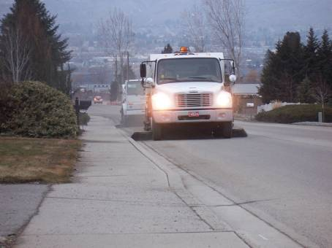
- Train operator on factors that influence pollutant removal, including sweeper speed, brush adjustment, rotation rate, sweeping pattern, and maneuvering around parked vehicles.
- Consider periodic parking restrictions to ensure curbs are cleared before sweeping takes place.
- Track street sweeping waste (total volume or weight per mile of road swept) and modify sweeping schedules based on accumulated sediment loads.
- Avoid wet cleaning or flushing and utilize dry methods whenever possible.
- If wet cleaning or flushing is absolutely necessary, sweep and remove debris prior to flushing; plug storm drain inlets and direct wash water to sanitary sewer (with prior approval from the local sewer agency).

Waste Disposal
Street waste is generally not considered a dangerous waste. However, high traffic loads or spills can lead to waste that requires special handling and disposal. Waste generated from street sweeping must be disposed of according to the requirements of <LOCAL SOLID WASTE AGENCY>. In some cases, the waste material must be tested to determine the proper disposal method. The <CITY/COUNTY>’s waste testing and disposal protocol is included in Appendix B.

Winter Activities

The <CITY/COUNTY> conducts winter activities such as anti-icing, deicing, sanding, snow plowing, and snow removal <Only keep those that apply> to enhance public safety during inclement winter weather. Proper selection and application of deicing chemicals is important to prevent negative environmental impacts to water quality and plants.

Anti-icing, Deicing and Sanding
- Select anti-icers and deicers that cause the least adverse environmental impact while still providing adequate public safety. The following materials are preferred:
  - <LIST>
  - <LIST>
- The following materials shall not be used:
  - <LIST>
  - <LIST>
- Follow manufacturer’s recommendations when applying chemical deicer.
- Calibrate equipment to optimum levels according to manufacturer instructions.
- Apply sand and deicers at the lowest rate necessary to provide for vehicle traction; avoid excessive application.
- Place barriers <LOCATION>, <LOCATION>, <LOCATION> to route deicing material away from water bodies. <Insert specific locations, such as along streams or direct surface water drainages.>
- Sweep streets in early spring to collect accumulated sand after the winter season.

Snow Removal
- Whenever possible, avoid covering inlets of the stormwater collection and conveyance system during plowing, so snowmelt can drain.
- Snow removed from <CITY/COUNTY> streets shall be taken to <LOCATION> for storage during melting.
- Snow shall not be disposed of within 25 feet of surface waters, 75 feet of private water supplies, 200 feet from any community water supply, or 400 feet from any municipal well.
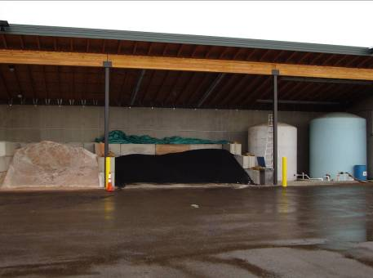

Material Storage
Uncovered material storage stockpiles are a major source of pollutants as sand, cinder, salts, or other road maintenance materials can be carried into the stormwater system during rain or snow melt events. Vehicle, equipment, and material storage areas should be maintained according to the SWPPP included in Appendix D. The following operational BMPs should be implemented to limit the transport of materials into the stormwater collection and conveyance system:
- Limit deicer and sand purchases to the amount that is expected to be needed for the upcoming season.
- Whenever possible, store material stockpiles in a building or within a paved and bermed covered area.
- Store chemical anti-icing and deicing materials following manufacturer recommendations.
- Sweep parking lots, material storage areas, and driveways regularly to collect dirt, waste, debris, and loose stockpile materials. Do not hose down the areas toward a storm drain inlet or ditch.
- Whenever possible, collect and recycle stored materials back into the stockpile.
- Place temporary plastic sheeting over uncovered stockpiles.

Street Repair and Maintenance

Street repair and maintenance activities include road surfacing (repairing potholes, sealing cracks, overlaying roads, and paving shoulders), pavement marking, signage and signal repairs, and small construction projects. The BMPs related to these activities are described below.

Street Repair and Maintenance BMPs
- When possible, avoid work in wet weather.
- Carry a spill kit during maintenance activities.
- Prevent paving materials, paint, pavement markings, and wastes from entering the storm drainage system.
- When placing chip seals, limit spreading aggregate to the sealed surface and sweep up excess aggregate once cured and each day thereafter until aggregate loss is insignificant.
- Collect any loose sand, gravel, asphalt, or other material as soon as possible after repair activities.
- Sweep or vacuum dust and debris before using water to clean up work sites.
- Avoid striping operations when the pavement is wet or if rain is likely.
- When striping, use water-based paints or thermoplastics rather than solvent-based materials.
- When possible, use portable drip trays under equipment to catch spills.
- Use dry cutting techniques with proper dust control when saw cutting and sweep or vacuum up residue. If wet cutting techniques are required, use as little cooling water as possible and switch the water off when the saw is not in use. Use downstream inlet protection to keep cutting waste out of the stormwater collection and conveyance system.
- Properly contain and dispose of unused paint, cleaning materials, and debris following repair activities.

Small Construction BMPs
The following BMPs apply when making small roadway repairs that include grading, soil transfer, or vegetation removal:
- Minimize land disturbance and exposed slope length.
- Whenever possible, avoid land disturbance during the wet season.
- Implement erosion control techniques or devices to stabilize disturbed areas. Use mulch or other erosion control measures when soils are exposed for more than a week.
- Install storm drain inlet protection on all inlets within <500 feet> downstream or down gradient of the project site to prevent coarse sediment from entering the drainage system. Inlet protection methods include block and gravel inlet protection, gravel and wire inlet protection, and catch basin inserts. Inspect inlet protections frequently during construction.
<500 feet is the recommended distance for small projects and the required distance for sites subject to the NPDES Construction Permit (i.e. sites larger than one acre).>
- Remove excess soil from the site as soon as possible after backfilling to eliminate sediment loss from surplus fill.
- <Required>Obtain a General NPDES Permit for Stormwater Discharges Associated with Construction Activities from Ecology for any project that disturbs one or more acres and has the potential to discharge to a water of the state.

For larger construction projects that create new impervious surfaces or have the potential to disturb large areas of soil, follow the construction activity guidelines in Section 8.

Vegetation Management

Vegetation management includes maintaining landscaping for roadway right-of-ways and medians and controlling noxious weeds, pests, and unwanted vegetation growth. Disturbed soil, removed vegetation, and chemicals can all negatively impact receiving waters.

Landscaping and Irrigation BMPs
- Maintain vegetative cover on medians and embankments to prevent soil erosion. When vegetation is removed, apply mulch or other cover measures to prevent soil erosion.
- Dispose of lawn clippings, leaves, branches, and other vegetative material at <LOCATION>; landscape material should not be disposed of in streams or storm drains.
- Avoid loosening the soil during weed control.
- Inspect the irrigation system regularly to minimize excess watering and prevent the runoff of fertilizer.
- Repair leaks to the irrigation system as soon as they are observed or reported.
- Minimize the use of chemical fertilizers and calibrate the distributor to avoid excessive application.
- <Required>Store fertilizers in enclosed areas or in covered impervious containment in accordance with the <CITY/COUNTY>‘s SWPPP. Store and maintain appropriate spill cleanup materials in a location known to all near the storage area.

Pesticide and Herbicide BMPs
- Follow the <CITY/COUNTY>‘s Integrated Pest Management Policy in Appendix E regarding landscape management decisions. <OR> Use integrated best management practices that consider cultural, biological, mechanical, or engineering controls before chemical controls.
- Use mechanical methods of vegetation removal rather than herbicides.
- Use pesticides only if there is an actual pest problem (not as a regularly scheduled preventative maintenance measure).
- Use the least toxic pesticide for the job; avoid the use of copper-based pesticides if alternatives are available; select products with low water solubility and low persistence.
- Do not use pesticides or herbicides if rain is expected.
- Do not mix or prepare pesticides near storm drain inlets.
- Follow product labels for proper application of any pesticide.
- Use the minimum amount of chemical needed for the job.
- Avoid pesticide applications within 100 feet of a water body and avoid application on or near most stormwater collection and conveyance facilities, excluding dry roadside ditches.
- Use products specifically labeled for dry ditches when treating roadside ditches.

Storage and Disposal
- <Required>Follow federal, state, and local laws governing the storage and disposal of pesticides and herbicides.
- <Required>Store herbicides/pesticides in enclosed areas or in covered impervious containment in accordance with the <CITY/COUNTY>‘s SWPPP. Store and maintain appropriate spill cleanup materials in a location known to all near the storage area.
- Rinse water from equipment cleaning and/or from herbicide/pesticide/fertilizer containers should be used as product, recycled into product, or disposed of properly.
- Following use, dispose of unused pesticide as hazardous waste.

Recordkeeping

Recordkeeping is a condition of the Phase II Permit. <NAME/TITLE> is responsible for keeping records of road and parking lot maintenance activities that have the potential to impact stormwater. The recordkeeping required by the Phase II Permit is limited to documenting any liquid or material spills that could carry pollutants into the stormwater collection and conveyance system. Spills should be reported to <NAME> and all paperwork related to the spill and cleanup activities should be maintained at <LOCATION.>

The following records may also assist the <NAME/TITLE> in planning for future maintenance activities:
- Street sweeping – location, frequency;
- Total volume/weight of materials collected per mile of road swept;
- Winter de-icing/sanding activities – location, type, frequency;
- Amount of street waste removed, and
- Results of sediment testing.
<These record keeping suggestions are optional. List those that are applicable, useful, and practical for your jurisdiction.>

Hard copy reports should be stored in <LOCATION>. <OR> Hard copy documents should be scanned for electronic storage in <LOCATION>. Street sweeping records should also be imported into the <CITY/COUNTY>’s GIS system, so the <TITLE> can geographically track maintenance activities and plan for future work.

This page intentionally left blank.

Table 5-1
Implementation Checklist
Vehicle Fleets
Potential Pollutants: Sediment, Hydrocarbons, Heavy Metals, Toxic Chemicals, Debris/Litter
 | Current Activity | Required New Activity* | Optional | Responsibility
Sweep vehicle storage parking lot monthly |  | X
Maintain spill kit onsite at all times | X
Conduct employee training on fueling procedures | X
Conduct all vehicle washing at an offsite commercial washing facility | X
Add elements
Add elements
*All required new activities must be implemented prior to the August 2011 to be in compliance with the Phase Permit.
< The table above is an example and should be tailored to the unique maintenance program of your jurisdiction. List current maintenance activities/frequencies, required new (or changed) activities, and optional activities – those items that maintenance crews should address as staff/time/budget are available.>

Overview

The <DEPARTMENT> is responsible for maintaining <CITY/COUNTY> vehicles and equipment in proper working order. Most vehicle maintenance is conducted at the <LOCATION>. Vehicle maintenance activities have the potential to spill or leak fluids, fuel, or other polluting liquids. Vehicle washing can also contribute soap, debris, and pollutants into the stormwater collection and conveyance system.

Standards and BMP Selection

The Phase II Permit does not include specific maintenance standards or BMPs related to the maintenance of vehicle fleets. The <CITY/COUNTY>’s obligation is to prevent the discharge of pollutants to the stormwater system and protect water quality to the maximum extent practicable. To meet that goal, the <CITY/COUNTY> has identified BMPs related to each of the following activities:
- Vehicle Storage Areas
- Vehicle Fueling
- Vehicle Maintenance
- Vehicle Washing
- Recordkeeping

In general, the focus on selecting vehicle fleet BMPs is to prevent spills and reduce the potential for non-stormwater discharges into the into the stormwater collection and conveyance system. Implementing these BMPs will help prevent the discharge of pollutants into receiving waters.

<Unless otherwise indicated, the BMPs in the remainder of Section 5 are recommendations only. Select those BMPs that make sense for your jurisdiction. >

Vehicle Storage

When vehicles and equipment are parked or stored outside without cover they have the potential to leak or drip hazardous fluids that can be carried to the stormwater system during a rain or snow melt event. The <CITY/COUNTY>‘s primary vehicle storage area is located at <LOCATION OF EQUIPMENT YARD>. Passenger vehicles are also stored overnight in the <PUBLIC WORKS PARKING LOT or OTHER>. In addition to the following BMPs, the <VEHICLE STORAGE YARD> should be maintained according to the SWPPP included in Appendix D.
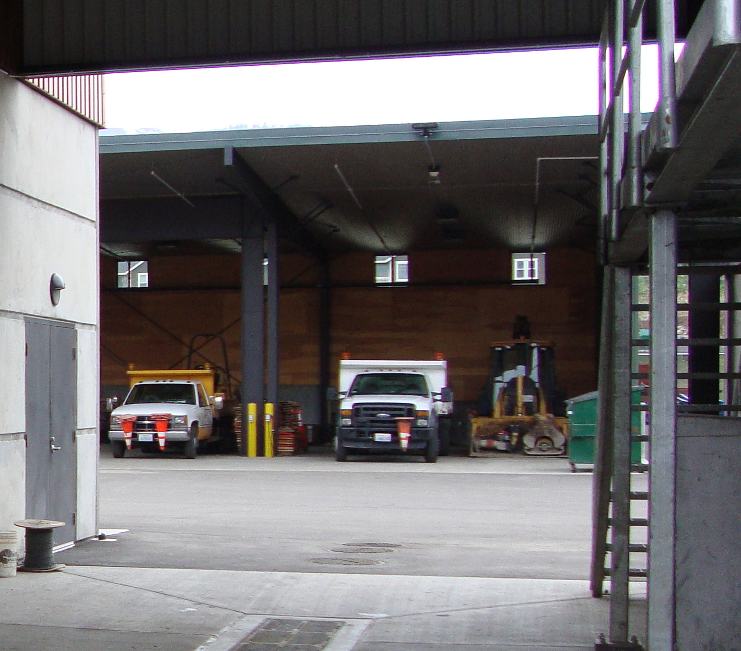

Operational BMPs
- Sweep parking lots, storage areas, and driveways regularly to collect dirt, waste, and debris. Do not hose down the areas to a stormwater conveyance system.
- Use drip pans or containers under vehicles and equipment that drip or are likely to drip liquids.
- Remove liquids from vehicles retired for scrap.

Structural BMPs
- <Required>Implement Structural BMPs to address vehicle storage areas in accordance with the <CITY/COUNTY>’s SWPPP.
- <Required>Install an oil removal system (API, baffle type, or coalescing plate oil water separator, catch basin filter, or equivalent structural BMP) at the vehicle storage area. <This BMP applies to fueling areas that meet Ecology’s “High Use” site characteristics: storage areas with 25 or more diesel vehicles over 10 tons gross weight; or ADT > 100 vehicles per 1,000 sf of building area.>

Vehicle Fueling

<Delete this section if no fueling is performed on City/County property.>
The <CITY/COUNTY> operates a fueling station at <LOCATION>. The following BMPs should be implemented to minimize contact between stormwater runoff and spilled fuel, oil or other leaked vehicle fluids at equipment fueling areas.
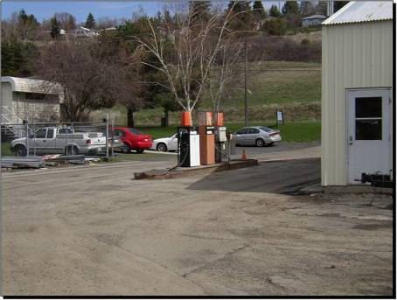

Operational BMPs
- <Required>Fuel tanks and fuel dispensers shall have current permits with the appropriate agencies.
- Prepare an emergency spill response plan and have a designated trained person(s) available either on site or on call at all times to promptly and properly implement that plan and immediately clean up all spills.
- <Required>Maintain a spill kit onsite at all times.
- Train employees on the proper use of fuel dispensers. Proper fueling and spill cleanup instructions shall be posted at fueling areas. Post signs in accordance with the Uniform Fire Code.
- Make sure that the automatic shutoff on the fuel nozzle is functioning properly.
- The person conducting the fuel transfer must be present at the fueling pump during fuel transfer, particularly at unattended or self-serve stations.
- Hosing down of leaks, drips and spills is prohibited.

Structural BMPs
- <Required>Install an oil removal system (API, baffle type, or coalescing plate oil water separator, catch basin filter, or equivalent structural BMP) at the vehicle fueling area. <This BMP applies to fueling areas that meet Ecology’s “High Use” site characteristics: storage areas with 25 or more diesel vehicles over 10 tons gross weight; or ADT > 100 vehicles per 1,000 sf of building area.>

Vehicle Maintenance

Vehicle and equipment maintenance and repair conducted by the <CITY/COUNTY> may include vehicle fluid removal, engine and parts cleaning, body repair and painting. If conducted outdoors, all of these activities have the potential to discharge pollutants into the stormwater system.

Operational BMPs
- Whenever possible, conduct vehicle maintenance indoors or within a paved, bermed and covered area.
- Outdoor vehicle and equipment maintenance shall not be performed during rain events or prior to predicted rain events unless required by emergency conditions.
- Maintenance activity areas should be kept clean, well organized and equipped with cleanup supplies.
- Inspect for leaks all incoming vehicles, parts, and equipment stored temporarily outside.
- Use absorbent pads, drip pans or absorbent material as appropriate. If rags and absorbents are saturated or contaminated with high concentrations of regulated hazardous materials, dispose of rags and absorbents according to hazardous waste disposal guidelines.
- <Required>Vehicle maintenance activities (fluid removal, engine and parts cleaning, and body repair and painting) should be done in accordance with the <CITY/COUNTY>’s SWPPP.

Vehicle Washing
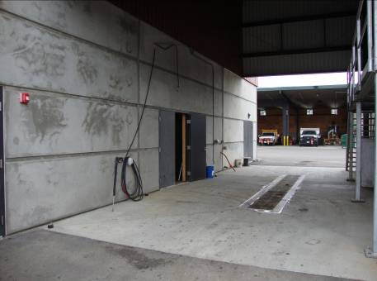
In accordance with the <CITY/COUNTY>’s Illicit Discharge Ordinance <ORDINANCE REFERENCE>, vehicle wash water is prohibited from entering the stormwater collection and conveyance system. In addition to the potential impacts from soapy water, wash water may contain other hazardous vehicle fluids. The <CITY/COUNTY> primarily washes vehicles at <Describe the facility where vehicles are washed or the location where vehicles are taken for washing.>

Operational BMPs
- Vehicle and equipment washing areas should be inspected daily and cleaned as needed.
- Mark the wash area.
- Use phosphate-free biodegradable soaps and detergents whenever practical.
- Do not remove original product label from cleaning containers as it contains important spill cleanup and disposal information. Use the entire product before disposing of the container.
- Minimize water usage.
- Conduct vehicle/equipment washing off-site at a commercial washing facility in which the washing occurs in an enclosure and drains to the sanitary sewer (with prior approval from the local sewer agency for the connection).

Structural BMPs
- If vehicle washing is to be conducted onsite, construct a designated vehicle wash location, including a covered wash pad, containment berms, and a drains connected to the sanitary sewer system (with prior approval).

Recordkeeping

The Phase II Permit requires long term recordkeeping of events and activities that have the potential to impact stormwater. The recordkeeping required by the Phase II Permit is limited to documenting any liquid or material spills that could carry pollutants into the stormwater collection and conveyance system. Material or liquid spills should be promptly reported to <NAME> and all paperwork related to the spill and cleanup activities should be maintained at <LOCATION.>

This page intentionally left blank.

Table 6-1
Implementation Checklist
Municipal Buildings
Potential Pollutants: Sediment, Nutrients, Hydrocarbons, Heavy Metals, Toxic Chemicals, Debris/Litter
 | Current Activity | Required New Activity* | Optional | Responsibility
Maintain a spill kit onsite at all times | X
Cover storm drain inlets prior to pressure washing |  | X
Inspect the irrigation system monthly during the watering season | X
Develop a Vegetation and Pest Management Plan |  | X
Add elements
Add elements
*All required new activities must be implemented prior to the August 2011 to be in compliance with the Phase Permit.
< The table above is an example and should be tailored to the unique maintenance program of your jurisdiction. List current maintenance activities/frequencies, required new (or changed) activities, and optional activities – those items that maintenance crews should address as staff/time/budget are available.>

Overview

Municipal building maintenance includes cleaning, washing, painting, and landscape maintenance. Potential pollutants from these activities include organic compounds, oil and grease, soap, heavy metals, and particulate matter. The <DEPARTMENT> is responsible for the maintenance of the <CITY/COUNTY>‘s municipal buildings including:
- <LIST>
- <LIST>
- <LIST>
- <LIST>

Standards and BMP Selection

The Phase II Permit does not include specific maintenance standards or BMPs related to the maintenance of municipal buildings. The <CITY/COUNTY>’s obligation is to prevent the discharge of pollutants to the stormwater system and protect water quality to the maximum extent practicable. To meet that goal, the <CITY/COUNTY> has identified BMPs related to each of the following activities:
- General Facility Housekeeping
- Building Cleaning and Washing
- Painting
- Vegetation Maintenance
- Winter Activities
- Recordkeeping

In general, the goals in selecting municipal building maintenance BMPs are to prevent spills, to reduce the potential for a non-stormwater discharge into the stormwater collection and conveyance system, and to reduce the amount of sediment and debris that is washed into the stormwater collection and conveyance system. Implementing these BMPs will help prevent the discharge of pollutants into receiving waters and help reduce the cost of maintaining the stormwater collection and conveyance system.

<Unless otherwise indicated, the BMPs in the remainder of Section 6 are recommendations only. Select those BMPs that make sense for your jurisdiction. >

General Facility Housekeeping

The purpose of general facility housekeeping is to keep municipal areas clean and free of debris and other pollutants that could be washed into the stormwater collection and conveyance system during a rainfall event. General facility housekeeping also includes storing materials under cover and handling materials and waste products in a way that minimizes the risk to stormwater.

Operational BMPs
- Keep open areas clean and orderly.
- Pick-up litter.
- Promptly contain and clean up solid and liquid pollutant leaks and spills.
- Sweep paved material handling and storage areas regularly.
- Inspect all structural BMPs regularly, particularly after a significant storm.
- Use drip pans or absorbent pads under leaking vehicles and equipment to capture fluids.
- Promptly remove debris and old equipment.
- Store hazardous materials as specified by the manufacturer.
- Conduct regular employee training to reinforce proper housekeeping actions.

Building Cleaning and Washing

Municipal building cleaning and washing activities may include washing of carpet and other interior items and/or conducting pressure washing of buildings, rooftops, and other large structures associated with a municipal building. Wash water from municipal building washing practices has the potential to be contaminated with pollutants harmful to stormwater such as sediment and chemicals.
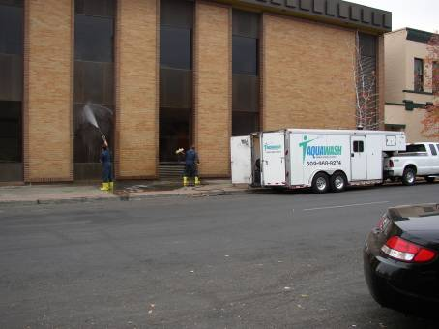

Operational BMPs
- Dispose of carpet or interior wash water to the sanitary sewer (with prior approval from the local sewer agency). Do not dispose of any wash water outdoors or to a storm drain system.
- <Required> Report any spills or accidental discharges to the storm drain system to <NAME>.
- Collect wash water from building structures and convey it to an appropriate treatment device, such as the sanitary sewer system (with prior approval). If wash water contains oils, soaps, or detergents, it may be directed to soils that have sufficient natural attenuation capacity for dust and sediment. A sump pump, wet vacuum, or similarly effective device may be used to collect the runoff and loose materials.
- Use storm drain covers for any inlets in the vicinity of the work area when conducting pressure washing activities. The cover(s) must be in place prior to engaging in the washing activity. Collect any accumulated runoff and solids with a wet vacuum or broom, and properly dispose of wastes before removing the cover(s) at the end of the work day.

Painting

Painting activities associated with interior or exterior municipal buildings include surface preparation and application of paints, stains, finishes and other coatings. Paints, stains, and finishes contain harsh chemicals and will contaminate stormwater if allowed to comingle.

Operational BMPs
- Never dump any toxic substance or liquid waste on the pavement or the ground.
- <Required>Report any spills or accidental discharges to the storm drain system to <NAME>.
- Train employees in the careful application of paints, finishes, stains, and coatings to reduce misuse and over spray.
- Use ground cloths or drop cloths underneath outdoor painting, scraping, sandblasting work, paint mixing, and tool cleaning.
- Wipe up spills with rags and other absorbent materials immediately. Do not hose down the area to a storm drain, receiving water, or conveyance ditch that drains to a receiving water.
- Clean brushes and tools covered with non-water based paints, finishes, or other materials in a manner that allows collection of used solvents (e.g., paint thinner, turpentine, xylol, etc.) for recycling or proper disposal.
- Store toxic materials under cover (tarp, etc.) during precipitation events and when not in use to prevent contact with stormwater.

Structural BMPs
- Enclose and(or) contain all work while using a spray gun or conducting sand blasting in compliance with applicable air pollution control, Occupational Safety and Health Administration, and Washington Industrial Safety and Health Act.

Vegetation Management

Vegetation management includes maintaining landscaping for landscaped areas associated with municipal buildings and controlling noxious weeds, pests, and unwanted vegetation growth. Disturbed soil, removed vegetation, and chemicals can all negatively impact receiving waters.

Landscaping and Irrigation BMPs
- Dispose of lawn clippings, leaves, branches, and other vegetative material at <LOCATION>; landscape material should not be disposed of in streams or storm drains.
- Inspect the irrigation system regularly to minimize excess watering and prevent the runoff of fertilizer.
- Repair leaks to the irrigation system as soon as they are observed or reported.
- Minimize the use of chemical fertilizers and calibrate the distributor to avoid excessive application.
- <Required> Store fertilizers in enclosed areas or in covered impervious containment in accordance with the <CITY/COUNTY>‘s SWPPP. Store and maintain appropriate spill cleanup materials in a location known to all near the storage area.

Pesticide and Herbicide BMPs
- Follow the <CITY/COUNTY>‘s Integrated Pest Management Policy in Appendix E regarding landscape management decisions. <OR> Use integrated best management practices that consider cultural, biological, mechanical, or engineering controls before chemical controls.
- Use mechanical methods of vegetation removal rather than herbicides.
- Use pesticides only if there is an actual pest problem (not as a regularly scheduled preventative maintenance measure).
- Use the least toxic pesticide for the job; avoid the use of copper-based pesticides if alternatives are available; select products with low water solubility and low persistence.
- Do not use pesticides or herbicides if rain is expected.
- Do not mix or prepare pesticides near storm drain inlets.
- Follow product labels for proper application of any pesticide.
- Use the minimum amount of chemical needed for the job.
- Avoid pesticide applications within 100 feet of a water body and avoid application on or near most stormwater collection and conveyance facilities.

Storage and Disposal
- <Required> Follow federal, state, and local laws governing the storage and disposal of pesticides and herbicides.
- Store herbicides/pesticides in enclosed areas or in covered impervious containment in accordance with the <CITY/COUNTY>‘s SWPPP. Store and maintain appropriate spill cleanup materials in a location known to all near the storage area.
- Rinse water from equipment cleaning and/or from herbicide/pesticide/fertilizer containers should be used as product, recycled into product, or disposed of properly.
- Following use, dispose of unused pesticide as hazardous waste.

Winter Activities

Winter activities around municipal buildings includes anti-icing, deicing, sanding, and snow removal <Only keep those that apply.> on sidewalks and small parking lots. (Winter activities related to large parking lots are discussed in Section 4.) These activities enhance protect public safety during inclement winter weather. In addition to the BMPs described below, see Section 4 for BMPs related to storage of sand and deicer.

Deicing and Sanding
- Whenever possible, limit the use of chemical deicers. When chemical application is needed, select produces with the least adverse environmental impact while still providing for public safety. The following materials are preferred:
  - <List>
  - <List>
- The following materials shall not be used:
  - <List>
  - <List>
- Apply sand and deicer at the lowest rate necessary to provide for public safety; avoid excessive application.
- Sweep parking lots in early spring to collect accumulated sand after the winter season.

Snow Removal
- Whenever possible, avoid piling snow over inlets of the stormwater collection and conveyance system so snow melt can drain.
- Snow removed from sidewalks and municipal parking lots shall be deposited on adjacent landscaped, within a seldom used parking stall, or taken to <LOCATION> for storage during melting.
- Avoid depositing snow within 25 feet of surface waters, 75 feet of private water supplies, 200 feet from any community water supply, or 400 feet from any municipal well.

Other Maintenance Activities

Additional maintenance activities associated with municipal buildings include building repair, remodeling, and construction projects.
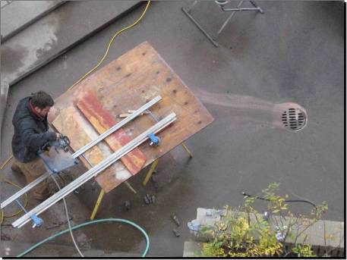

Operational BMPs
- Use a storm drain cover if dust, grit, wash water, or other pollutants have the potential to enter a storm drain inlet. Collect any accumulated runoff and solids with wet vacuums and brooms as needed.
- Use ground cloths or drop cloths underneath outdoor painting, scraping, and sandblasting work and properly dispose of collected material daily.
- Use a ground cloth or oversized tub for activities such as paint mixing and tool cleaning.
- <Required> Store and maintain a spill control kit and ensure employees are familiar with proper spill control procedures.
- <Required> Report spills or accidental discharges to the stormwater conveyance system to <NAME>.

Structural BMPs
- Stencil drywell and catch basin grates with, “Dump No Waste - Drains to River/Groundwater".

Recordkeeping

The Phase II Permit requires long term recordkeeping of events and activities that have the potential to impact stormwater. The recordkeeping required by the Phase II Permit is limited to documenting any liquid or material spills that could carry pollutants into the stormwater collection and conveyance system. Material or liquid spills should be promptly reported to <NAME> and all paperwork related to the spill and cleanup activities should be maintained at <LOCATION.>

This page intentionally left blank.

Table 7-1
Implementation Checklist
Parks and Open Space
Potential Pollutants: Sediment, Nutrients, Heavy Metals, Pathogens, Toxic Chemicals, Debris/Litter
 | Current Activity | Required New Activity* | Optional | Responsibility
Minimize use of chemical fertilizers |  | X
Inspect irrigation systems monthly during the watering season | X
Develop a Vegetation and Pest Management Plan |  | X
Install covered trash containers in all parks | X
Install pet waste kiosks in all parks |  |  | X
Add elements
Add elements
*All required new activities must be implemented prior to the August 2011 to be in compliance with the Phase Permit.
< The table above is an example and should be tailored to the unique maintenance program of your jurisdiction. List current maintenance activities/frequencies, required new (or changed) activities, and optional activities – those items that maintenance crews should address as staff/time/budget are available.>

Overview

The maintenance of parks and open space areas frequently includes fertilization, mowing, pesticide application, and supplemental irrigation. Potential pollutants from these activities include nutrients, chemicals, organic debris, and sediment. Improving the way park and open space maintenance activities are conducted can reduce the amount of stormwater pollution that is conveyed to local aquatic resources.

The <DEPARTMENT> is responsible for the maintenance of the following park properties:
- <PARK NAME>
- <PARK NAME>
- <PARK NAME>
- <PARK NAME>

The <DEPARTMENT> is responsible for maintaining open space and undeveloped properties owned by the <CITY/COUNTY>. These properties include:
- <LIST>
- <LIST>
<List major open space/undeveloped properties.>

Standards and BMP Selection

Unless park areas include stormwater management facilities, the Phase II Permit does not include specific maintenance standards or BMPs related to the maintenance of parks and open space. (BMPs for maintenance of stormwater management facilities are included in Section 3). The <CITY/COUNTY>’s obligation is to prevent the discharge of pollutants to the stormwater system and protect water quality to the maximum extent practicable. To meet that goal, the <CITY/COUNTY> has identified BMPs related to each of the following activities:
- Vegetation Management
- Trash and Debris
- Small Construction Projects
- Buildings and Structures
- Stormwater Facilities
- Storage Areas
- Recordkeeping

In general, the goals in selecting park and open space maintenance BMPs are to prevent spills, to reduce the potential for a non-stormwater discharge into the stormwater collection and conveyance system, and to reduce the amount of sediment and debris that is washed into the stormwater collection and conveyance system. Implementing these BMPs will help prevent the discharge of pollutants into receiving waters and help reduce the cost of maintaining the stormwater collection and conveyance system.

<Unless otherwise indicated, the BMPs in the remainder of Section 7 are recommendations only. Select those BMPs that make sense for your jurisdiction. >

Vegetation Management

Proper turf management and landscape maintenance practices have the potential to reduce the amount of stormwater runoff and the amount of pollutants that drain to receiving waters. Vegetated spaces provide an excellent opportunity to infiltrate precipitation as it falls and filter pollutants before they can be washed downstream. Vegetation management includes maintaining landscaping throughout park and open space area and controlling noxious weeds, pests, and unwanted vegetation growth. BMPs should be used to prevent disturbed soil, removed vegetation, and chemicals from causing a negative impact to receiving waters.

Vegetation Management BMPs
- Maintain vegetative cover on medians and embankments to prevent soil erosion. When vegetation is removed, apply mulch or other cover measures to prevent soil erosion.
- Allow natural revegetation in suitable areas and clearly designate “no mow” areas.
- Use mulching type mowers or dispose of lawn clippings at <LOCATION OF COMPOSTING FACILITY>.
- Dispose of vegetated waste (clippings, leaves, branches) at <LOCATION OF COMPOSTING FACILITY>; landscape material should not be disposed of in streams or storm drains.
- Avoid loosening the soil during weed control.
- Do not use leaf blowers to blow waste into streets, storm drains, or ditches.
- Minimize the use of chemical fertilizers and calibrate the distributor to avoid excessive application.
- Never apply fertilizer within 5 feet of pavement, 25 feet of a storm drain inlet, or 50 feet of a stream or water body.
- <Required>Store fertilizers in enclosed areas or in covered impervious containment in accordance with the <CITY/COUNTY>‘s SWPPP. Store and maintain appropriate spill cleanup materials in a location known to all near the storage area.

Irrigation BMPs
- Inspect the irrigation system regularly to minimize excess watering and prevent the runoff of fertilizer.
- Repair leaks to the irrigation system as soon as they are observed or reported.
- Use soaker hoses, rather than sprinklers; irrigate in the morning or evening to conserve water.
- Monitor soil for moisture content and adjust irrigation times accordingly.

Pesticide and Herbicide BMPs
- Follow the <CITY/COUNTY>‘s Integrated Pest Management Policy in Appendix E regarding landscape management decisions. <OR> Use integrated best management practices that consider cultural, biological, mechanical, or engineering controls before chemical controls.
- Use mechanical methods of vegetation removal rather than herbicides.
- Use pesticides only if there is an actual pest problem (not as a regularly scheduled preventative maintenance measure).
- Use the least toxic pesticide for the job; avoid the use of copper-based pesticides if alternatives are available; select products with low water solubility and low persistence.
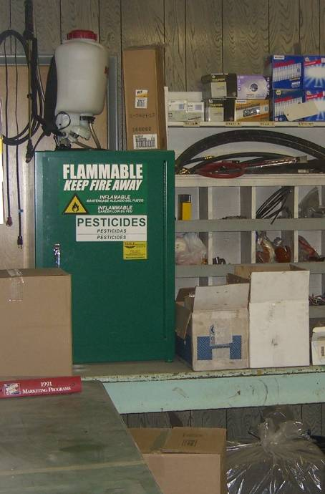
- Do not use pesticides or herbicides if rain is expected.
- Do not mix or prepare pesticides near storm drain inlets.
- Follow product labels for proper application of any pesticide.
- Use the minimum amount of chemical needed for the job.
- Avoid pesticide applications within 100 feet of a water body and avoid application on or near most stormwater collection and conveyance facilities, excluding dry roadside ditches.
- Use products specifically labeled for dry ditches when treating roadside ditches.

Storage and Disposal
- <Required>Follow federal, state, and local laws governing the storage and disposal of pesticides and herbicides.
- <Required>Store herbicides/pesticides in enclosed areas or in covered impervious containment in accordance with the <CITY/COUNTY>‘s SWPPP. Store and maintain appropriate spill cleanup materials in a location known to all near the storage area.
- Rinse water from equipment cleaning and/or from herbicide/pesticide/fertilizer containers should be used as product, recycled into product, or disposed of properly.
- Following use, dispose of unused pesticide as hazardous waste.

Trash and Debris

Trash and debris collection is important to maintain the aesthetic and livability of the <CITY/COUNTY>’s parks. Prompt trash removal also helps prevent garbage and leachate from entering the stormwater conveyance system and polluting receiving waters.

Trash and Debris Removal BMPs
- Cover garbage containers to prevent contact with precipitation. When possible, store garbage containers beneath covered structures.
- Locate dumpsters on a flat, concrete surface that does not slope or drain into the storm drain system.
- Regularly inspect garbage and recycling containers for cracks and leaks; make repairs promptly.
- <Required>Properly dispose of hazardous waste, gasoline, oil, and other chemical liquids. Never dispose of hazardous waste in park dumpsters or garbage containers.
- Consider the installation of pet waste kiosks, providing signage and collection bags, to encourage responsible pet waste clean-up.

Small Construction Activities

The following BMPs apply when small construction or repair activities include grading, soil transfer, or vegetation removal.

Small Construction BMPs
- Minimize land disturbance and exposed slope length.
- Whenever possible, avoid land disturbance during the wet season.
- Implement erosion control techniques or devices to stabilize disturbed areas. Use mulch or other erosion control measures when soils are exposed for more than a week.
- Install storm drain inlet protection on all inlets within <500 feet> downstream or down gradient of the project site to prevent coarse sediment from entering the drainage system. Inlet protection methods include block and gravel inlet protection, gravel and wire inlet protection, and catch basin inserts. Inspect inlet protections frequently during construction.
<500 feet is the recommended distance for small projects and the required distance for sites subject to the NPDES Construction Permit (i.e. sites larger than one acre).>
- Remove excess soil from the site as soon as possible after backfilling to eliminate sediment loss from surplus fill.
- <Required>Obtain a General NPDES Permit for Stormwater Discharges Associated with Construction Activities from Ecology for any project that disturbs one or more acres and has the potential to discharge to a water of the state.

For larger construction projects that add new impervious surfaces, modify components of the stormwater system, disturb large areas of soil or include any in-water work, follow the construction activity guidelines in Section 8.

Buildings and Structures

The building facilities in <PARK NAME> and <PARK NAME> shall be maintained according to the BMPs in Section 6 of this O&M Plan.

Stormwater Facilities

<Delete this section if the parks department does not conduct stormwater facility maintenance.>
The <DEPARTMENT> is responsible for the maintenance of stormwater management facilities in <PARK NAME> and <PARK NAME>. Stormwater management facilities should be inspected and maintained according to the schedules and maintenance standards in Section 3.
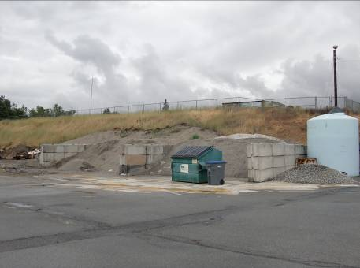

Storage Areas

Maintenance vehicles, equipment, and uncovered material stockpiles have the potential to leak or contribute pollutants to the stormwater system during rain or snow melt events. Vehicle, equipment, and material storage areas should be maintained according to the SWPPP included in Appendix D. The following operational BMPs should be implemented to limit the transport of materials into the stormwater collection and conveyance system:
- Sweep parking lots, material storage areas, and driveways regularly to collect dirt, waste, debris, and loose stockpile materials. Do not hose down the areas to a stormwater conveyance system.
- Whenever possible, store material stockpiles in a building or within a paved and bermed covered area. Place temporary plastic sheeting over stockpiles that are exposed to the elements.
- Whenever possible, collect and recycle stored materials back into the stockpiles.
- Park/store all vehicles and equipment in a designated covered containment area.
- Use drip pans or containers under vehicles and equipment that drip or are likely to drip liquids.

Recordkeeping

Recordkeeping is a condition of the Phase II Permit. <NAME/TITLE> is responsible for keeping records of stormwater collection and conveyance system maintenance activities within <NAME> Park and <NAME> Park. In accordance with the Phase II Permit, the following documentation must be kept for at least five years following work activity:
- Inspection schedules and checklists for stormwater management facilities;
- Records of spot checks performed following major storm events, and
- Repairs or maintenance actions completed as a result of inspections and spot checks.
<Delete the above paragraph if the parks department does not conduct stormwater facility maintenance.>

The recordkeeping required by the Phase II Permit is limited to documenting any liquid or material spills that could carry pollutants into the stormwater collection and conveyance system. Material or liquid spills should be promptly reported to <NAME> and all paperwork related to the spill and cleanup activities should be maintained at <LOCATION.>

Hard copy reports should be stored in <LOCATION>. <OR> Hard copy documents should be scanned for electronic storage in <LOCATION>. In addition, material or liquid spills should be promptly reported to <NAME> and all paperwork related to the spill and cleanup activities should be maintained at <LOCATION.>

This page intentionally left blank.

Municipal construction projects are subject to the same requirements as those projects proposed by private developers. During construction, proper erosion and sediment controls should be used to prevent sediment-laden stormwater from flowing away from the site and into the stormwater collection and conveyance system. Ecology requires construction sites of a certain size to document their planned sediment and erosion control techniques and to obtain separate NPDES Permit coverage.

The following construction projects are required to have a General NPDES Permit for Stormwater Discharges Associated with Construction Activities (Construction Permit). Refer to Ecology’s website or regional office for additional information.
- Clearing, grading and/or excavation (including forest practices) that results in the disturbance of one or more acres and discharges stormwater to surface waters of the State; or
- Clearing, grading and/or excavation on sites smaller than one or more acres that are part of a larger common plan of development or sale that will ultimately disturb one acre or more, and discharge stormwater to surface waters of the State; or
- Any size construction activity discharging stormwater to waters of the State that Ecology determines to be a significant contributor of pollutants to waters of the State of Washington or that Ecology reasonably expects to cause a violation of any water quality standard.

The following construction activities are exempt from NPDES permit coverage:
- Construction activities that discharge all stormwater and non-stormwater to ground water, and have no point source discharge to either surface water or a storm sewer system that drains to surface waters of the State.
- Construction activities covered under an Erosivity Waiver (Condition S2.C).
- Routine maintenance that is performed to maintain the original line and grade, hydraulic capacity, or original purpose of a facility.

Municipal projects that are subject to the NPDES Construction permit should refer to Ecology’s website for information regarding the required erosion and sediment control practices.

This page intentionally left blank.

The Department of Ecology issues the General NPDES Permit for Stormwater Discharges Associated with Industrial Activities (Industrial Permit) to authorize stormwater discharges associated with industrial activities. The current permit was put into effect as of January 1, 2010. The permit requires the development and implementation of a SWPPP and a sampling plan specific to the permitted facility. The <CITY/COUNTY> facilities currently covered under the Industrial Permit are:
- <LIST FACILITY>
- <LIST FACILITY>
- <LIST FACILITY>

In addition to the facilities listed above, any facility listed in Table 9-1 that discharges to surface water or into a storm drainage system that later discharges to a surface water is subject to the Industrial Permit and must obtain permit coverage from Ecology. This guidance table was adopted from Ecology’s Guidance Manual for Preparing/Updating a Stormwater Pollution Prevention Plan for Industrial Facilities.

Table 9-1
Examples of Facilities that Require an Industrial Permit
Municipal Industrial  Facilities | Description and SIC Codes
Hazardous Waste Treatment, Storage, or Disposal Sites | Including those operating under interim status or a permit under Subtitle C of the Resource Conservation and Recovery Act (RCRA).
Landfills, Land Application Sites, and Open Dumps | Facilities receive or have received any industrial wastes (waste that is received from any industrial facilities, including those subject to regulation under Subtitle D of RCRA).
Recycling Facilities | Facilities involved in recycling of materials, including metal scrap yards, battery reclaimers, salvage yards, and automobile recyclers, including but not limited to those classified as SIC 5015 and 5093.
Transportation Facilities | Those classified under the following SICs which have vehicle maintenance shops, equipment cleaning operations, or airport deicing operations: 40 – Railroad Transportation, 41 – Local and Interurban Passenger Transportation, 45 – Transportation by Air.
Sewage Treatment Plants | Those with a design flow of one million gallons per day or more.
Source: Stormwater Pollution Prevention and Good Housekeeping, Yakima County, 2010.

The following types of facilities do not need an Industrial Permit:
- Facilities that discharge all stormwater associated with industrial activity in to the ground (e.g. infiltration basins, dry wells, drain fields); with some exemptions.
- Facilities that discharge all stormwater to a combined sewer system.
- Facilities owned and operated by the federal government or are on Tribal land, or facilities that discharge directly to Tribal waters meeting Environmental Protection Agency (EPA) approved water quality standards.
- Facilities that qualify for “Conditional No Exposure.” However, facilities must re-apply every five years or 30 days after the effective date reissuance of the Industrial Permit, whichever comes first.

The NPDES Permit requires all material storage areas, heavy equipment storage areas, and maintenance areas to develop and implement a SWPPP to protect water quality and prevent the discharge of contaminated stormwater to surface or groundwater. The SWPPP describes both operational and structural BMPs that will be implemented at each facility.

The following <CITY/COUNTY> properties are covered by the SWPPP which is included in Appendix D.
- <NAME OF MUNICIPAL STORAGE AREA>
- <NAME OF MUNICIPAL STORAGE AREA>
<List all municipal storage facilities. Facilities covered under a NPDES Industrial Permit or other individual NPDES Permit do not need to be listed here.>

A copy of the SWPPP must also be kept on hand at each of the facilities listed above.

This page intentionally left blank.

Overview

The <CITY/COUNTY> owns and operates the following flood management facilities:
- <LIST FACILITY>
- <LIST FACILITY>
- <LIST FACILITY>
- <LIST FACILITY>

The <DEPARTMENT> is responsible for the design and review of proposed flood management projects. During the design of all new flood management projects, the <CITY/COUNTY>’s engineers will assess the water quality impacts of the proposed project and consider the use of controls to minimize impacts to site hydrology.

Standards and BMP Selection

The Phase II Permit does not include specific maintenance standards or BMPs related to the flood management projects. The Phase II Permit requires the <CITY/COUNTY> to “…assess water quality impacts in the design of all new flood management projects that are associated with the MS4 or that discharge to the MS4….” The <CITY/COUNTY> meets this obligation by reviewing all projects under <Reference Post-construction Stormwater Management Ordinance>.

As with all other maintenance activities, the <CITY/COUNTY>’s obligation during flood management facility maintenance is to prevent the discharge of pollutants to the stormwater system and protect water quality to the maximum extent practicable. To meet that goal, the <CITY/COUNTY> has identified the following BMPs.

<Unless otherwise indicated, the BMPs in the remainder of Section 11 are recommendations only. Select those BMPs that make sense for your jurisdiction. >

Inspections

Flood management facilities will be inspected regularly to identify maintenance needs. During inspections, field crews should utilize the inspection checklists in Appendix A to document the condition of each facility and identify any required maintenance activities. Any identified maintenance needs should be reported to <TITLE>, so that work orders can be developed to complete the required repair or cleaning.

<Required>All flood management facilities should be inspected on an annual basis and following any major precipitation events exceeding <1.3> inches of rainfall in any 24 hour period. <Insert 10-year precipitation value from isopluvial maps. 1.3 inches is conservatively low for most areas of Eastern Washington.>

Facility Maintenance

Routine facility maintenance often includes vegetation management, dike or levee repair, sediment removal, fence replacement, or access road repair. When flood management facilities require routine maintenance, implement the Stormwater Facility Maintenance BMPs outlined in Section 3.

Small Construction Activities

Sediment and erosion control measures should be implemented when small construction projects include grading, soil transfer, or vegetation removal. The following BMPs apply when making structural repairs or replacing components of flood management facilities:
- Minimize land disturbance and exposed slope length.
- Whenever possible, avoid land disturbance during the wet season.
- Implement erosion control techniques or devices to stabilize disturbed areas. Use mulch or other erosion control measures when soils are exposed for more than a week.
- Install storm drain inlet protection on all inlets within <500 feet> downstream or down gradient of the project site to prevent coarse sediment from entering the drainage system. Inlet protection methods include block and gravel inlet protection, gravel and wire inlet protection, and catch basin inserts. Inspect inlet protections frequently during construction.
<500 feet is the recommended distance for small projects and the required distance for sites subject to the NPDES Construction Permit (i.e. sites larger than one acre).>
- Remove excess soil from the site as soon as possible after backfilling to eliminate sediment loss from surplus fill.
- <Required>Obtain a General NPDES Permit for Stormwater Discharges Associated with Construction Activities from Ecology for any project that disturbs one or more acres and has the potential to discharge to a water of the state.

For larger construction projects that add impervious surface, modify the function of existing flood management facilities, or include any in-water work, follow the construction activity guidelines in Section 8.

Recordkeeping

Recordkeeping is a condition of the Phase II Permit. <NAME/TITLE> is responsible for keeping records of flood management activities that may impact receiving waters. In accordance with the Phase II Permit, the following documentation must be kept for at least five years following work activity:
- Inspection schedules and checklists for stormwater treatment and flow control facilities;
- Records of spot checks performed following major storm events, and
- Repairs or maintenance actions completed as a result of inspections and spot checks.

Hard copy reports should be stored in <LOCATION>. <OR> Hard copy documents should be scanned for electronic storage in <LOCATION>. Inspections, catch basin cleaning, and facility maintenance should also be imported into the <CITY/COUNTY>’s GIS system, so the <TITLE> can geographically track maintenance activities and plan for future work.

In addition, material or liquid spills should be promptly reported to <NAME> and all paperwork related to the spill and cleanup activities should be maintained at <LOCATION.>

This page intentionally left blank.

Table 12-1
Implementation Checklist
Other Facilities and Activities
Potential Pollutants: Sediment, Nutrients, Heavy Metals, Pathogens, Toxic Chemicals, Debris/Litter
 | Current Activity | Required New Activity* | Optional | Responsibility
Water/Sewer System
<ADD ELEMENTS>
<ADD ELEMENTS>
Dust Control
<ADD ELEMENTS>
<ADD ELEMENTS>
Fire Fighting
<ADD ELEMENTS>
<ADD ELEMENTS>
*All required new activities must be implemented prior to the August 2011 to be in compliance with the Phase Permit.
< The table above is an example and should be tailored to the unique maintenance program of your jurisdiction. List current maintenance activities/frequencies, required new (or changed) activities, and optional activities – those items that maintenance crews should address as staff/time/budget are available.>

The <CITY/COUNTY> also conducts several other maintenance activities that have the potential to impact stormwater runoff. This section covers the following municipal activities:
- Water System / Sewer System
- Dust Control
- Fire Fighting
- Airport
- Swimming Pools
- <OTHER>

<Only list those activities that apply to your community. Add or delete sections below as appropriate. Unless otherwise indicated, all BMPs in Section 12 are recommendations only. Select those BMPs that make sense for your jurisdiction. >

The BMPs associated with each activity are listed in the individual sections below.

Water System / Sewer System

The <CITY/COUNTY> is responsible for operation and maintenance of a <SIZE (i.e. NUMBER OF MILES OF PIPE OR SQUARE MILES OF SERVICE AREA)> water system and a <SIZE (i.e. NUMBER OF MILES OF PIPE OR SQUARE MILES OF SERVICE AREA)> sewer system. Maintenance and repairs to the water and sewer utility systems has the potential to impact receiving waters.
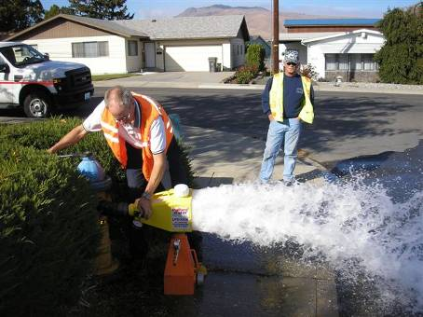

Water Line Flushing
The Phase II Permit allows planned discharges from potable water sources into the stormwater collection and conveyance system under certain conditions. These conditions apply to potable water line flushing, fire hydrant system flushing, and pipeline hydrostatic testing.

<Required>The velocity and volume of discharges must be controlled so as not to mobilize sediment deposits or cause soil erosion around the storm drain system.

<Required>Discharges must be dechlorinated to a concentration of 0.1 ppm or less and be pH-adjusted. Excessive chlorine concentrations may kill nitrifying bacteria and other aquatic life necessary for sustenance for the aquatic food chain. At the same time, overuse of common chemicals used for the dechlorination process has the potential to deplete dissolved oxygen or alter the pH of receiving waters.

The chlorine field test kit is kept at <LOCATION>. Every field personnel responsible for dechlorination activities shall be trained in proper use of the test kit. When water line flushing is likely to drain into the stormwater collection and conveyance system, the preferred dechlorination method is: <List those that apply.>
- Installing a venture-based dechlorination device on the end of a fire hose to feed chemical solutions into the chlorinated water flow,
- Using a dechlorinating diffuser and chemical tablet chamber,
- Laying a dechlorination mat or strip across the flow path and over the nearby storm drains to diffuse sodium sulfite into the chlorinated flow prior to discharge into the stormwater system.

Small Construction Activities
Sediment and erosion control measures should be implemented when water or sewer repair or replacement projects include grading, soil transfer, or vegetation removal. The following BMPs apply when making structural repairs or replacing components of the water or sewer utility infrastructure.
- Minimize land disturbance and exposed slope length.
- Whenever possible, avoid land disturbance during the wet season.
- Implement erosion control techniques or devices to stabilize disturbed areas. Use mulch or other erosion control measures when soils are exposed for more than a week.
- Install storm drain inlet protection on all inlets within <500 feet> downstream or down gradient of the project site to prevent coarse sediment from entering the drainage system. Inlet protection methods include block and gravel inlet protection, gravel and wire inlet protection, and catch basin inserts. Inspect inlet protections frequently during construction.
<500 feet is the recommended distance for small projects and the required distance for sites subject to the NPDES Construction Permit (i.e. sites larger than one acre).>
- Remove excess soil from the site as soon as possible after backfilling to eliminate sediment loss from surplus fill.
- <Required>Obtain a General NPDES Permit for Stormwater Discharges Associated with Construction Activities from Ecology for any project that disturbs one or more acres and has the potential to discharge to a water of the state.

For larger construction projects that include the addition of new stormwater system components or the replacement of culverts in streams or other perennial water bodies, follow the construction activity guidelines in Section 8.

Dust Control

Chemical based dust suppressants can be used to control dust and stabilize road surfaces. However, the chemicals used can have negative environmental impacts by decreasing dissolved oxygen in surface waters or increasing concentrations of iron, sulfur compounds, and other pollutants in groundwater.

Dust Control BMPs
- Follow product labels and maintain equipment for proper application of dust suppression chemicals.
- The <CITY/COUNTY> prefers the following dust suppression products:
  - <LIST>
  - <LIST>

<See Ecology Publication #96-433 for information on selecting the proper dust suppression methodologies for your situation.>
- Do not apply product during wet weather or prior to predicted rainfall that may wash the product from the surface.
- Restrict the use of product within 25 feet of a water body.
- Calibrate application equipment to evenly distribute product at the optimal rate to bind surfaces.
- Minimize dust generation and apply environmentally friendly and government approved dust suppressant chemicals, if necessary. Sprinkle or wet down soil or dust with water as long as it does not result in a wastewater discharge.

Fire Fighting

Emergency fire fighting activities are exempt from the conditions of the Phase II Permit. However, day to day operations are subject to the pollution prevention requirements. Vehicle and building maintenance activities at fire stations should implement the BMPs for vehicle fleets in Section 5 and the BMPs for municipal buildings in Section 6. For training exercises and fire hydrant system flushing, the Phase II Permit does allow planned discharges from potable water sources into the stormwater collection and conveyance system under certain conditions.

<Required>The velocity and volume of discharges must be controlled so as not to mobilize sediment deposits or cause soil erosion around the storm drain system.

<Required>Discharges must be dechlorinated to a concentration of 0.1 ppm or less and be pH-adjusted. Excessive chlorine concentrations may kill nitrifying bacteria and other aquatic life necessary for sustenance for the aquatic food chain. At the same time, overuse of common chemicals used for the dechlorination process has the potential to deplete dissolved oxygen or alter the pH of receiving waters.

The chlorine field test kit is kept at <LOCATION>. Every field personnel responsible for dechlorination activities shall be trained in proper use of the test kit. When fire hydrant flushing is likely to drain into the stormwater collection and conveyance system, the preferred dechlorination method is: <List those that apply.>
- Installing a venture-based dechlorination device on the end of a fire hose to feed chemical solutions into the chlorinated water flow,
- Using a dechlorinating diffuser and chemical tablet chamber,
- Laying a dechlorination mat or strip across the flow path and over the nearby storm drains to diffuse sodium sulfite into the chlorinated flow prior to discharge into the stormwater system.

Airport

Operations and maintenance activities at <AIRPORT NAME> have the potential to impact receiving waters. The <DEPARTMENT> is responsible for airport maintenance including maintaining the stormwater drainage system, parking lots, buildings, vehicles, and landscaping. The <DEPARTMENT> manages runway and taxiway operations, including the application of anti-icing or deicing compounds.

Airport Maintenance BMPs
<Insert BMPs from previous O&M Plan Sections as appropriate.>

Swimming Pools

Building maintenance activities at <LIST FACILITY> should implement the BMPs for municipal buildings in Section 6. In addition to the potential impacts from building maintenance, chlorinated pool water poses an additional threat to aquatic species. Excessive chlorine concentrations may kill nitrifying bacteria and other aquatic life necessary for sustenance for the aquatic food chain.

Swimming Pool Maintenance BMPs
- Pool water must be dechlorinated to a concentration of 0.1 ppm or less, volumetrically controlled to prevent the mobilization of sediments, and pH adjusted prior to discharge to the stormwater collection and conveyance system.
- Pool water that cannot meet the requirements for discharge to the stormwater system must be discharged to the sanitary sewer system with prior approval from the local sewer authority.
- During pool maintenance, discharge filter backwash and wastewater from pool maintenance (i.e. acid cleaning) to sanitary sewer system with prior approval from the local sewer agency.

<Other>

<Use this section to add additional activities and BMPs as needed>

This page intentionally left blank.

The focus of this O&M Plan is to implement activities and practices that will protect receiving waters. Most of the BMPs included in this plan require minor adjustments to behaviors during existing maintenance activities. The <DEPARTMENT> is responsible for implementing the new activities associated with the stormwater collection and conveyance system inspections and maintenance requirements outlined in Section 3. The <DEPARTMENT> will also need to adjust street sweeping practices and winter activities to comply with the BMPs included in Section 4.

Management Philosophy

This O&M Plan was developed to meet the requirements of the NPDES Phase II Permit. The Permit includes required inspection schedules and maintenance standards for the stormwater collection and conveyance system. Beyond that, the Permit is prescriptive when it comes to implementing BMPs for other <CITY/COUNTY> departments. Instead, the BMPs in this plan have been selected based on the requirements to “…reduce the discharge of pollutants to the maximum extent practicable (MEP)” (Permit Section S4.C) and to “…use all known, available, and reasonable methods of prevent, control and treatment (AKART) to prevent and control pollution of waters of the State of Washington.” (Permit Section S4.D)

The BMPs and activity schedules in this O&M Plan have also been developed based on:
- The level of service expected by local citizens;
- The level of service requested by the <CITY COUNCIL/COUNTY COMMISSION/PUBLIC WORKS MANAGEMENT>; and
- The maintenance frequencies needed to prevent costly repairs of the stormwater collection and conveyance system.

For example, the Phase II Permit does not have required street sweeping frequencies, so the frequencies listed in this plan are those necessary to maintain aesthetics, prevent excessive build-up of sediment in catch basins, and prevent significant trash, debris, and sediment accumulation in bike lanes.

The Staffing and Equipment spreadsheet included in Appendix F shows a detailed breakdown of the staff hours, equipment needs, and overall costs to implement the activities and frequencies presented in this O&M Plan. Program costs may be adjusted by changing the desired level of service for various aspects of the <CITY/COUNTY>’s infrastructure and municipal facilities.

Staff Assignments and Work Orders

<Optional text section>
Based on the Staffing and Equipment calculations, the staff time required for stormwater pollution prevention breaks down into the following major activities:
- Stormwater Collection and Conveyance: <##> Full Time Equivalents (FTE)
- Roads and Parking Lots: <##> FTE
- Fleet and Vehicles: <##> FTE
- Municipal Buildings: <##>FTE
- Parks and Open Space: <##> FTE
- Flood Management Projects: <##> FTE
- Other Activities: <##> FTE
- Program Management: <##> FTE

Note that the above staff requirements are only for the stormwater pollution prevention activities related to each maintenance area. For example, the <##> FTE(s) for roads and parking lots include the time for street sweeping, sanding, and plowing, but does not include the time for pothole repair or sign replacement.
<Note that the Staffing and Equipment spreadsheet can be expanded to include all maintenance needs. If so, adjust the descriptions in this Section accordingly.>

<NAME> is responsible for developing <DAILY/WEEKLY> work orders and making crew assignments to implement the practices and activities outlined in this O&M Plan.

<Describe how the Plan will translate into staff assignments.>

Annual Budget

<Describe the annual budget requirements based on the staffing and equipment spreadsheet. Some sample text is included below.>
The cost of implementing this O&M Plan for all <CITY/COUNTY> facilities and operations is expected to be <$DOLLARS> on an annual basis. The cost of the maintenance activities can be phased in over the next <NUMBER> years.

Of the total cost, approximately <$DOLLARS> or <PERCENT %> of the total will be needed to maintain the stormwater collection and conveyance system in accordance with the Phase II Permit requirements. The majority of the cost increase over current expenditures is needed to conduct annual inspections of all components of the stormwater system. Over time, these annual inspections will allow the <CITY/COUNTY> to adjust crew assignments to focus maintenance activities on neighborhoods and facilities that experience the most problems. Recurring problem areas can also be identified for long term retrofit to address the challenges.

Equipment Needs

<Describe equipment needs to implement the O&M Plan as developed. Consider opportunities to share equipment with neighboring communities.>
The <CITY/COUNTY> is generally well equipped to address the maintenance needs identified in this O&M Plan. A <LIST MAJOR EQUIPMENT NEED> is needed in the next 1 – 2 years to <DESCRIBE NEED>. Over the next 1 – 2 years, some other minor equipment purchases are needed including:
- <LIST>
- <LIST>
- <LIST>

In the longer term, the <CITY/COUNTY> will need to replace the <LIST MAJOR EQUIPMENT> in the next 3 – 5 years and the <LIST MAJOR EQUIPMENT> in approximately ten years.

Coordination with Phase II Permit

This O&M Plan is focused on meeting the requirements of Section S5.B.6 of the Phase II Permit. However, a number of other permit requirements are intertwined with the <CITY/COUNTY>’s operations and maintenance activities. Implementing this O&M Plan will assist the <CITY/COUNTY> with compliance with the following:

Illicit Discharge Detection and Elimination
Field inspectors play a key role in verifying and updating information in the <CITY/COUNTY>’s stormwater system inventory. Field inspectors and maintenance crews are also the front lines for identifying spills and potential illicit discharge concerns. Illicit discharge issues will be promptly reported to <NAME/TITLE> and all paperwork related to the spill and cleanup activities should be maintained at <LOCATION>. In addition, the spill clean-up training required under Section S5.B.3 is applicable to spills of potential pollutants during municipal maintenance activities.

Recordkeeping
The Phase II Permit focuses primarily on keeping records of activities related to inspection, maintenance, and repair of the stormwater collection and conveyance system. The inspection checklists in Appendix A are a key component to the <CITY/COUNTY>’s recordkeeping system. As described in Section 3, the Phase II Permit requires that the following documentation be kept for at least five years following work activity:
- Inspection schedules and checklists for stormwater treatment and flow control facilities;
- Records of spot checks performed following major storm events,
- Repairs or maintenance actions completed as a result of inspections and spot checks,
- Number and type of enforcement actions related to private facilities, and
- Number and type of illicit discharges detected and eliminated.

In addition, tracking the following information may be helpful in planning and budgeting for future maintenance activities.
- Catch basins cleaned each year,
- Amount of sediment collected and date removed,
- Results of sediment testing,
- Street sweeping – location, frequency;
- Total volume/weight of materials collected per mile of road swept;
- Winter de-icing/sanding activities – location, type, frequency;
- Amount of street waste removed, and
- Results of sediment testing.
<These record keeping suggestions are optional. List those that are applicable, useful, and practical for your jurisdiction.>

<NAME/TITLE> is also responsible for keeping records of crew activities for the overall maintenance program. This information can be compared against the staffing and equipment spreadsheet (Appendix F) on a quarterly or annual basis to evaluate whether staffing and equipment predictions are accurate. To facilitate this comparison, it may be necessary to add new timesheet codes to the <CITY/COUNTY>’s reporting system.

Annual Report
Inspection checklists and maintenance records developed during the implementation of this O&M Plan will assist the <CITY/COUNTY> in completing the Phase II Permit annual report that must be submitted to Ecology by March 31 of each year. While the maintenance records do not need to be submitted with the annual report, the <CITY/COUNTY> does have an obligation to supply Ecology with the records if requested.

