Appendix C

Private Facility Inspection and Enforcement Protocol

Private Facility Inspection and Enforcement Protocol

<CITY/COUNTY>

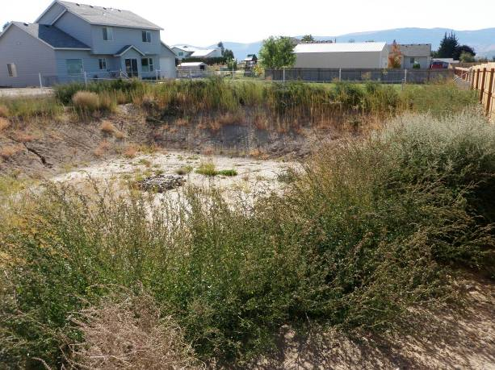
The Eastern Washington Phase II Municipal Stormwater Permit (Permit) requires that the <CITY/COUNTY> protect water quality and reduce the discharge of pollutants into receiving waters. As part of the Permit, the <CITY/COUNTY> must reduce pollutant discharges from stormwater management facilities through implementation of the Construction and Post-Construction Ordinance (<ORDINANCE REFERENCE>) and the <NAME/DATE OF O&M PLAN>.

This protocol outlines the <CITY/COUNTY>’s procedures for ensuring private stormwater facilities are maintained according to <CITY/COUNTY> standards. The facilities that may be impacted include privately owned and maintained ponds, tanks, vaults, swales and other stormwater management facilities that drain to the public municipal separate storm sewer system (MS4). The MS4 includes the public storm sewer pipe system, as well as ditches, creeks, and rivers.
(The CITY/COUNTY may choose to expand the inspection program to include infiltrating facilities, but it is not a requirement of the Permit.)

Transfer of Ownership
The <CITY/COUNTY> may assume ownership of privately-owned facilities where there is a regional benefit to the utility and if certain conditions stated in <ORDNANCE REFERENCE> have been met.

Inspection and Enforcement
The <CITY/COUNTY>’s Construction and Post-Construction Stormwater Ordinance (<ORDINANCE REFERENCE>) states that all privately-owned stormwater facilities that discharge to the public stormwater collection and conveyance system (including pipes, ditches, creeks, and rivers) shall be subject to inspection by the <CITY/COUNTY PUBLIC WORKS DIRECTOR>. These facilities must be maintained in accordance with the <CITY/COUNTY>’s O&M Plan (<TITLE AND DATE OF PLAN>). The following protocol describes the <CITY/COUNTY>’s procedures for inspecting and enforcing maintenance standards for private facilities.

<Select the option below that best fits your jurisdiction and revise/modify the steps as needed.>

<Option 1: Owners of private facilities perform facility inspection and complete report>
Overview: Owners of private stormwater facilities assume the responsibility of maintaining their facilities in a manner that prevents stormwater pollution and maintains the original function of the facility. Maintenance activities include annual inspections, record keeping, and reporting.

The <CITY/COUNTY> inspection program includes the following procedures:
- The private facility inspection program is the responsibility of <TITLE/DEPARTMENT>.
- The <CITY/COUNTY> maintains a map and database of private facilities that discharge to the <CITY/COUNTY>’s stormwater conveyance system. The information is stored in the GIS basemap <NAME> in the layer file <SHAPEFILE NAME>.
- The <CITY/COUNTY> will send a reminder letter to all affected facility owners in <MONTH> of each year. The letter includes a required completion date for facility inspections, instructions for completing an inspection, and the applicable inspection checklist from Appendix A of the O&M Plan. (Alternatively, post the inspection checklists online and direct owners to the City’s website.)
- Private facilities are to be inspected annually by a third party hired by the facility owner. Identified maintenance activities must be completed prior to <DATE>. Inspection and maintenance records must be submitted to the <CITY/COUNTY> by <DATE>.
- <TITLE> will review all inspection and maintenance reports and enter the information in the private facility database. Inspection and maintenance records will be maintained for at least five (5) years.
- The <CITY/COUNTY> will send a reminder letter to all private facility owners that have not returned an inspection report in <MONTH>.
<Include steps for follow-up and enforcement actions specific to your jurisdiction. Some considerations:
- Will the City/County conduct inspections for those owners who do not meet the due date?
- Will there be a late fee, fine, or enforcement action for those who miss the due date?
- Will there be an inspection fee if the City/County has to conduct the inspection?
- Will any spot-checks be performed to verify inspections (not required)?
- Include references to relevant ordinances for fines, fees, and other enforcement procedures.>

<Option 2: City/County performs facility inspections and owner performs maintenance>
Overview: The <CITY/COUNTY> assumes responsibility for inspection of all private stormwater facilities. The inspection program includes record keeping and reporting. The <CITY/COUNTY> will inform each facility owner of maintenance actions that are necessary to maintain the facility in a manner that prevents stormwater pollution and maintains the original function of the facility. Private owners must perform or hire crews to perform the maintenance actions and submit records to the <CITY/COUNTY> for long term record keeping.

The <CITY/COUNTY> inspection program includes the following procedures:
- The private facility inspection program is the responsibility of <TITLE/DEPARTMENT>.
- The <CITY/COUNTY> maintains a map and database of private facilities that discharge to the <CITY/COUNTY>’s stormwater conveyance system. The information is stored in the GIS basemap <NAME> in the layer file <SHAPEFILE NAME>.
- Structural BMPs (ponds, swales, vaults, tanks, etc.) shall be inspected at least once every <THREE> years. The <DEPARTMENT> shall develop a geographically-based schedule for annual facility inspection to indicate which facilities are inspected in a given year.
- Permit requires inspection every five years, “…or more frequently as determined by the Permittee to be necessary to prevent adverse water quality impacts, to ensure that adequate maintenance is performed.”
- It is the owner’s responsibility to maintain access to facilities for inspection purposes. Inaccessible facilities will subject the owner to enforcement action under <ORDINANCE REFERENCE>.
- The <CITY/COUNTY> will perform private facility inspections in <JULY/AUGUST/SEPTEMBER> of the appropriate year. Field inspectors will use the inspection checklists in Appendix A of the O&M Plan to document conditions at each private facility.
- The <CITY/COUNTY> will send a letter with the inspection report to the owner by <# DAYS> after inspection. The report will identify all required maintenance activities necessary for each facility and a required date of completion.
- Identified maintenance activities must be completed by the owner prior to <DATE>. Maintenance records must be submitted to the <CITY/COUNTY> by <DATE>.
- <TITLE> will review all maintenance reports and enter the information in the private facility database. Inspection and maintenance records will be maintained for at least five (5) years.
- The <CITY/COUNTY> will send a reminder letter to all private facility owners that have not completed the required maintenance in <MONTH>.
<Include steps for follow-up and enforcement actions specific to your jurisdiction. Some considerations:
- Will the City/County conduct follow-up inspections to verify maintenance has been completed (not required)?
- Will there be a late fee, fine, or enforcement action for those that miss the due date?
- Does the City/County have authority to perform maintenance and bill the private owner for the cost?
- Include references to relevant ordinances for fines, fees, and other enforcement procedures.>

